Omni-Channel Retail Hub

|  |  |
| --- | --- |
| Document Date  26-Mar-2022 | Created By  Hein Thant Toe |
| Version  Version 1.0 | Status  updating |
|  |  |

CONTENT

1. Technology Usage 4

2. Company Management System Flow 4

3. High Level System Flow 5

4. E-Commerce Flow 6

5. Facebook Integration Flow 7

6. Viber Integration Flow 7

7. System Administrator Flow 8

8. System User Flow 8

9. ACE Subscriptions 9

10. Backend 9

10.1 Log In & Register 9

10.2 Admin Module 10

10.2.1 User 11

10.2.2 Menu 13

10.2.3 Role 14

10.2.4 Authorization 15

10.2.5 Assign User Roles 16

10.2.6 Company Information 17

10.3 Master Data Configuration 19

10.3.1 Category 21

10.3.2 Group 22

10.3.3 Class 23

10.3.4 UM (Unit of Measurement) 24

10.3.5 Currency 25

10.3.6 Currency Rate 26

10.3.7 State, District, Township 28

10.3.8 Package Type 29

10.3.9 Delivery Type 30

10.3.10 Delivery Zone 32

10.3.11 Delivery Rate 34

10.3.12 Payment Type 36

10.3.13 Payment Rate 38

10.3.14 Product Code Setup 40

10.3.15 Unit Rate 43

10.3.16 Price Sheet Setup 45

10.3.17 Inventory Location 48

10.3.18 Opening Balance 49

10.3.19 Customer Type 51

10.3.20 Customer 53

10.3.21 Price Sheet for Customer Type 54

10.3.22 Main Code Import 56

10.3.23 Main Code Export 57

10.4 Page Setting Module 57

10.4.1 Advertisement 57

10.4.2 Contact Us 59

10.4.3 Privacy & Policy 60

10.5 Sale Module 61

10.5.1 Sale Order Edit 62

10.5.2 Sale Order Update 65

10.5.3 Sale Order Export 66

10.6 Delivery Module 67

10.6.1 Route 67

10.6.2 Route Schedule 69

10.6.3 Daily Route Information 72

10.6.4 Cash Collect 73

10.7 Multi-Channel Integration 75

10.7.1 Sale Content 77

10.7.2 Sale Content Posting 78

10.7.3 Advertisement Content 79

10.7.4 Advertisement Posting 80

10.8 Analysis Report Information 81

10.8.1 Multi-Channel Analysis Information 81

10.8.2 Sale Order Information 83

10.9 Dashboard Information 85

11. Front End 87

11.1 Log In 88

11.2 Register 89

11.3 Home Page 89

11.4 Shop Page 90

11.4.1 Detail Page 91

11.5 Contact Us Page 93

11.6 Privacy & Policy Page 94

# Technology Usage

**Programming Language**

Back end = C# .net core 3.1

Front end = JavaScript, Bootstrap, Jquery, Ajax

Database = MySQL 8.0.21s

# Company Management System Flow

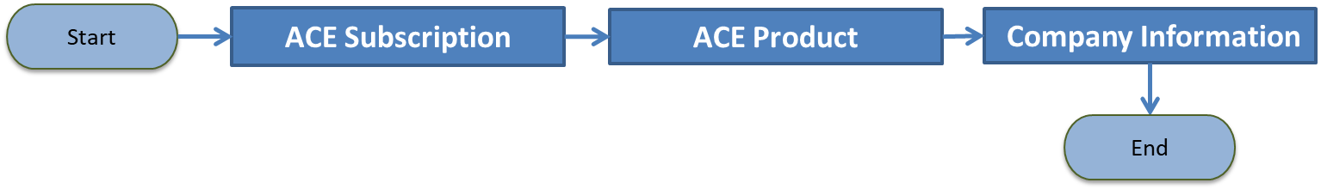

**Table Structure**

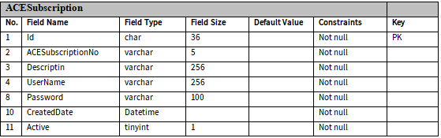

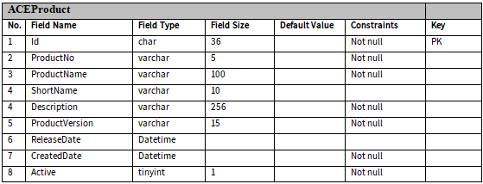

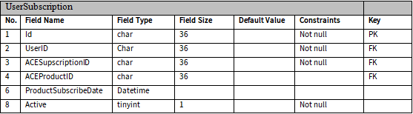

# High Level System Flow

|  |  |  |  |
| --- | --- | --- | --- |
| C:\Users\HP\Pictures\OCRH\Customer.png | Customers | C:\Users\HP\Pictures\OCRH\SaleMan.png | Sale Men |
| C:\Users\HP\Pictures\OCRH\Delivery Man.png | Delivery Men | C:\Users\HP\Pictures\OCRH\Accountant1.png | Accountant |
| C:\Users\HP\Pictures\OCRH\SA.png | System Admin | C:\Users\HP\Pictures\OCRH\Users.png | System User |

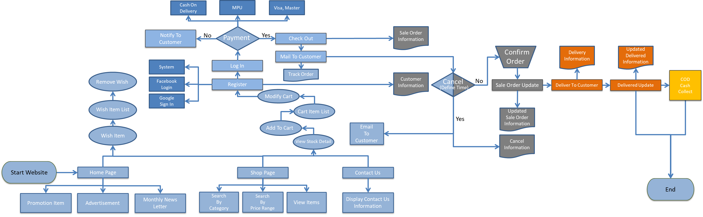

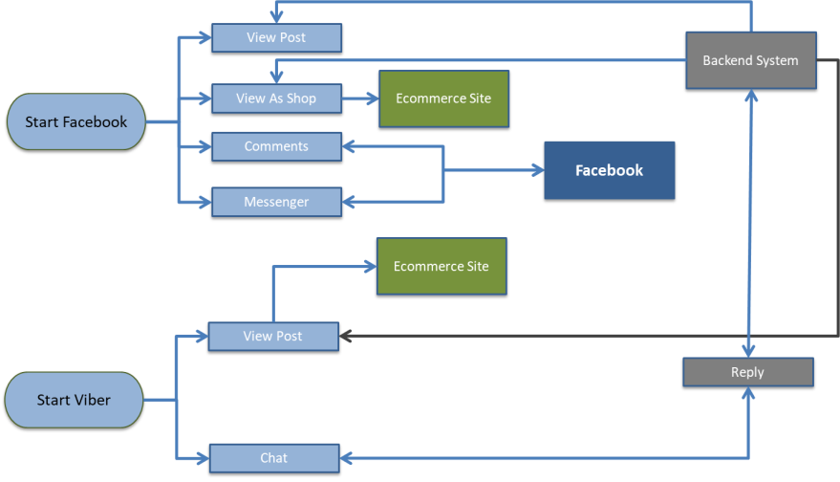

# E-Commerce Flow

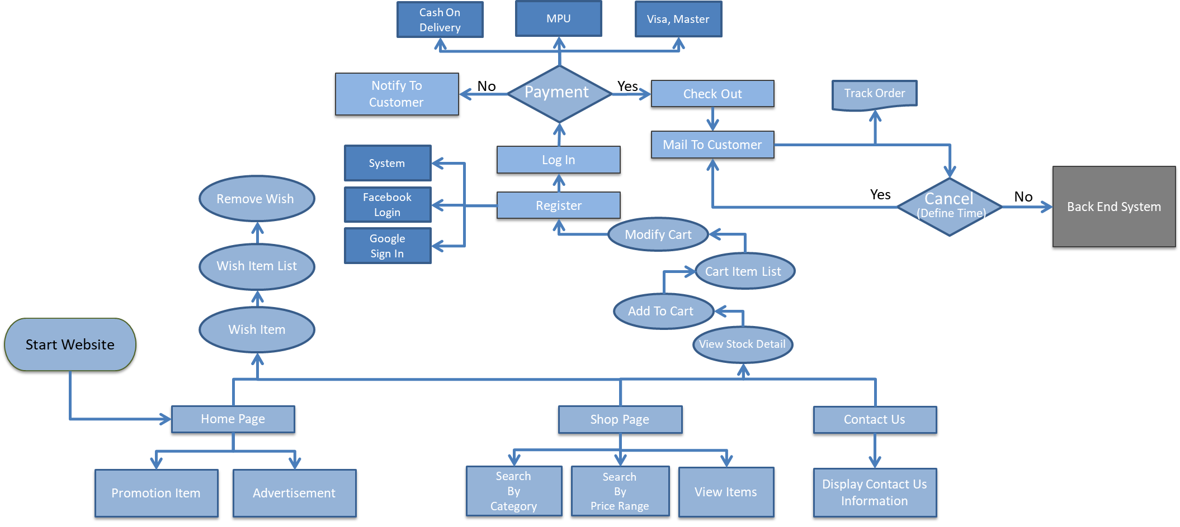

## * Balance Check Process Flow



# Facebook Integration Flow

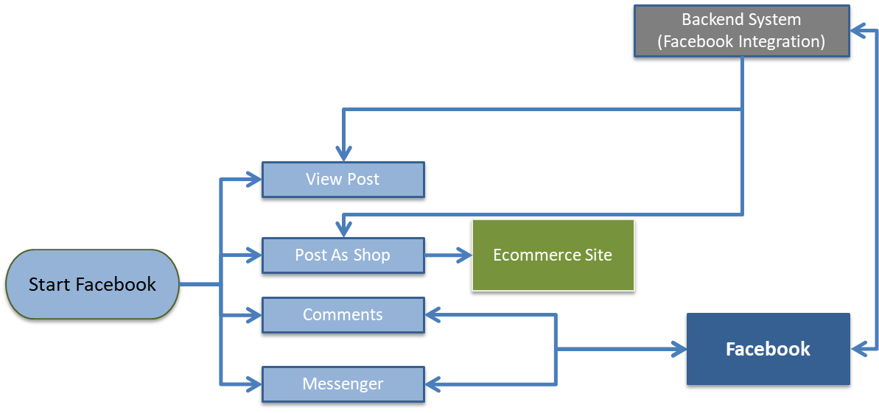

# Viber Integration Flow

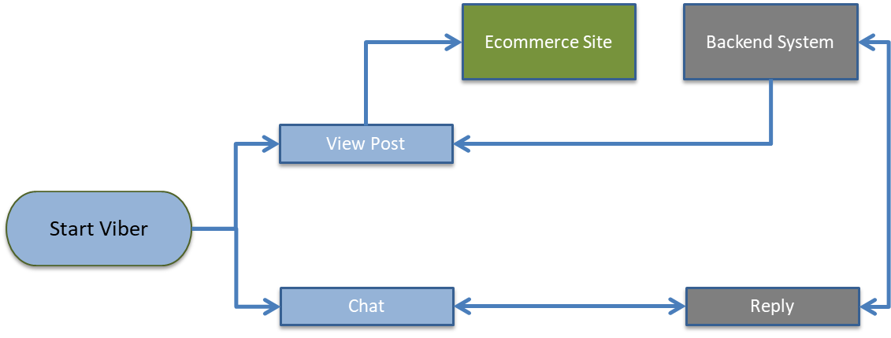

# System Administrator Flow

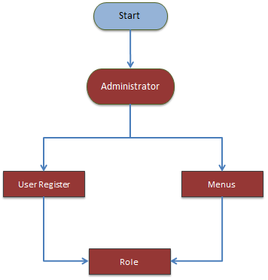

# System User Flow

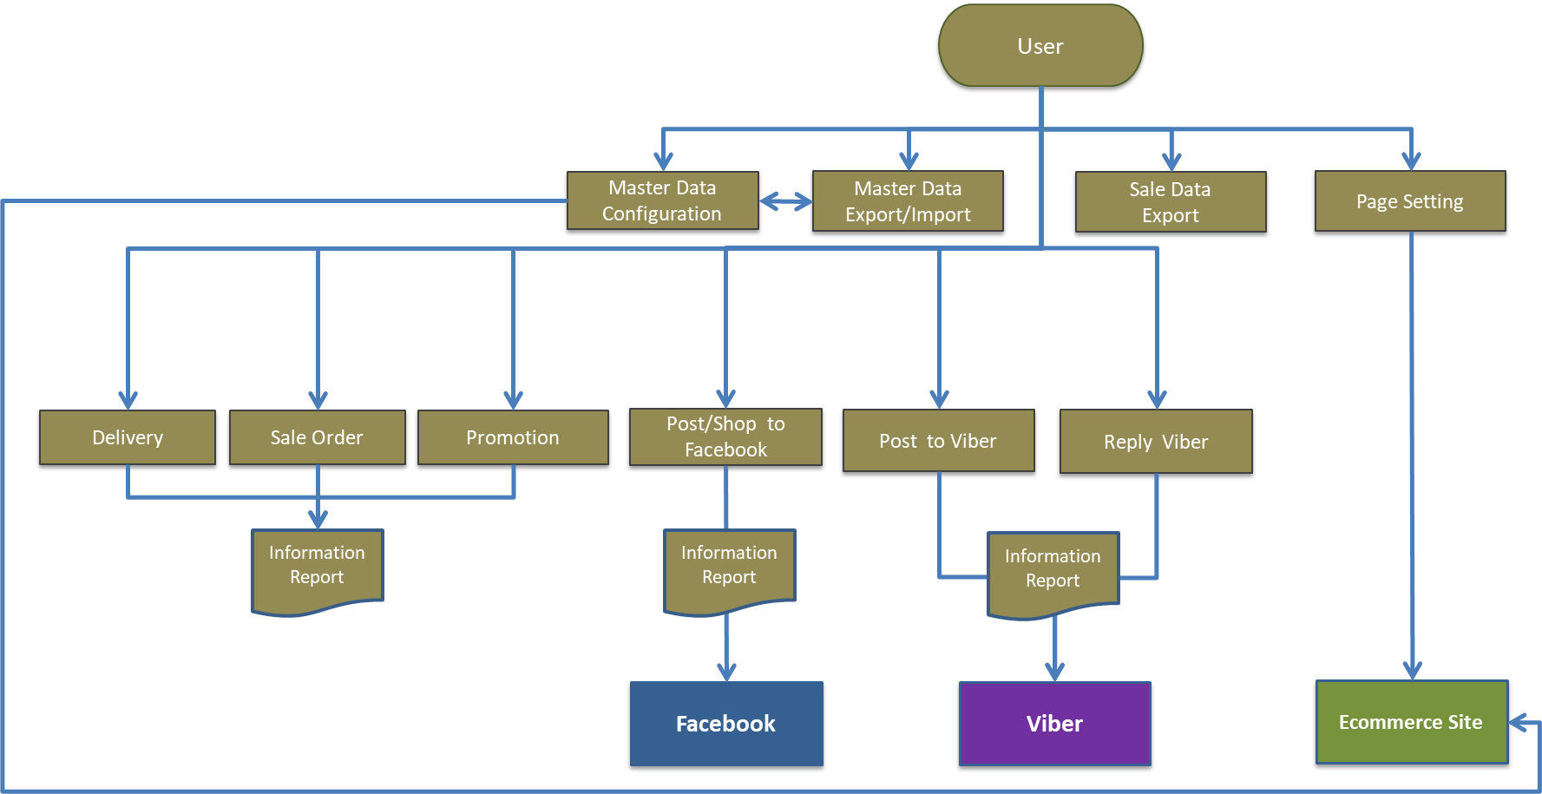

# ACE Subscriptions

**Process Flow**

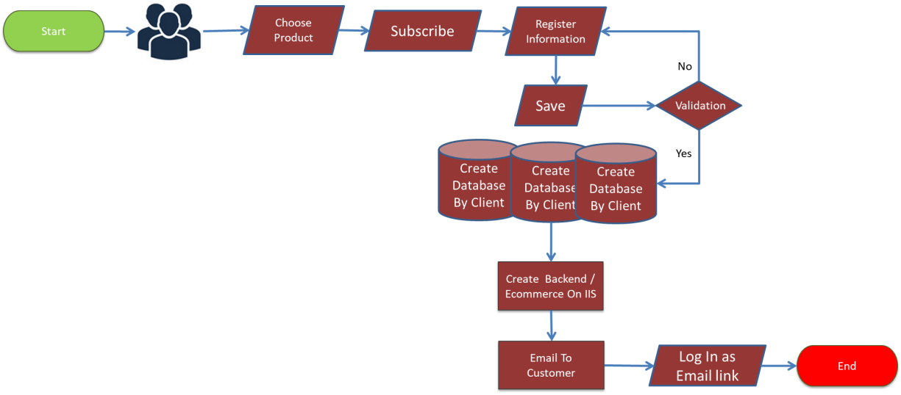

# Backend

## Log In & Register

**Process Flow**

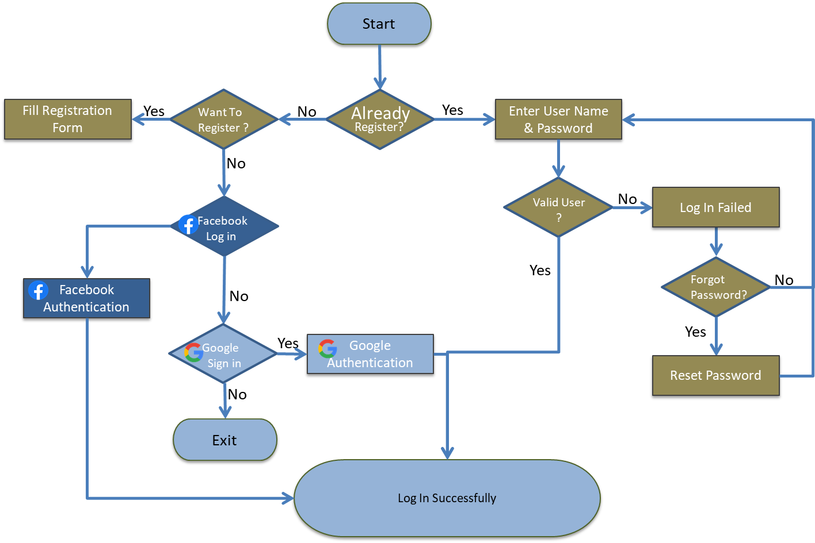

**Log In**

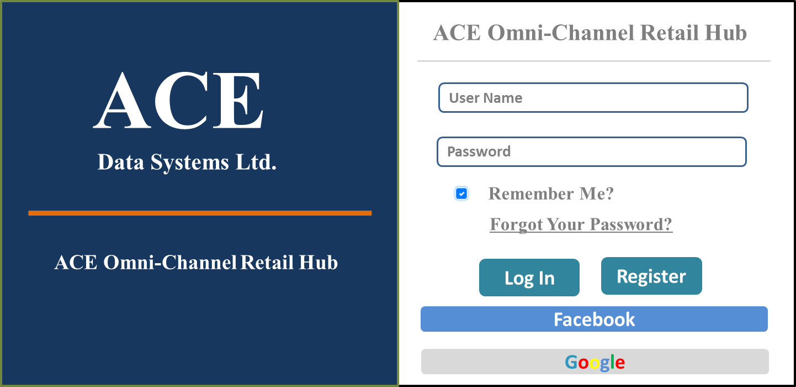

**Register**

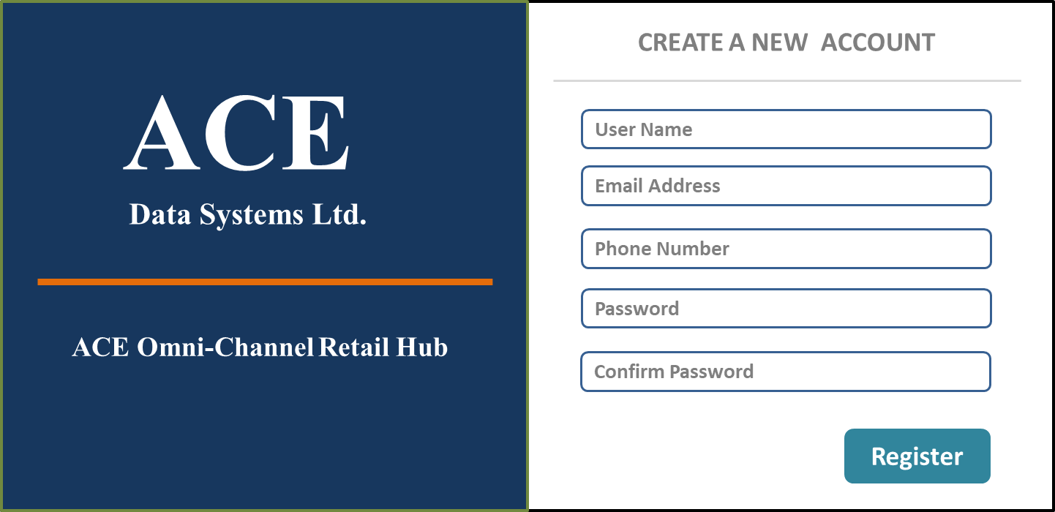

## Admin Module

**Entity Relationship Diagram**

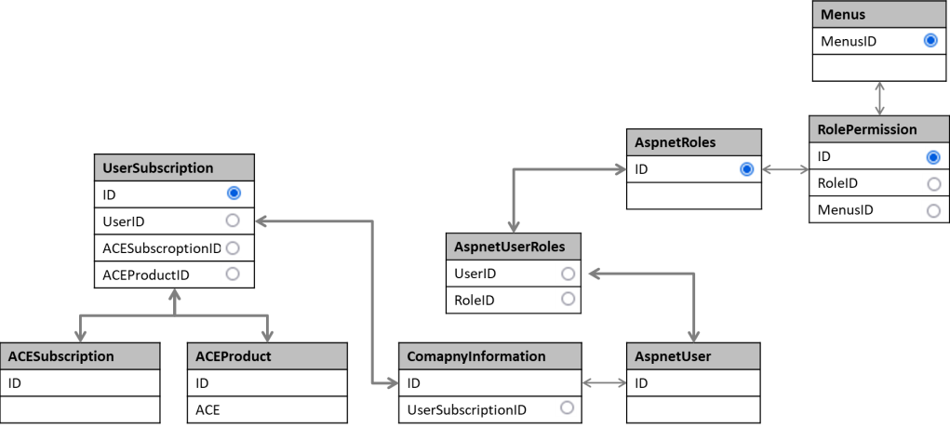

### User

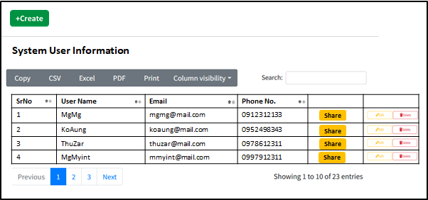

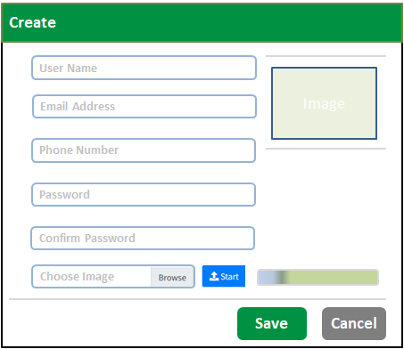

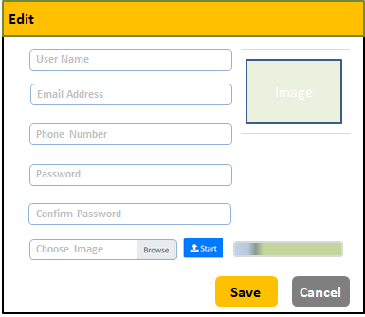

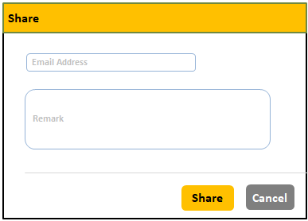

**Table Structure**

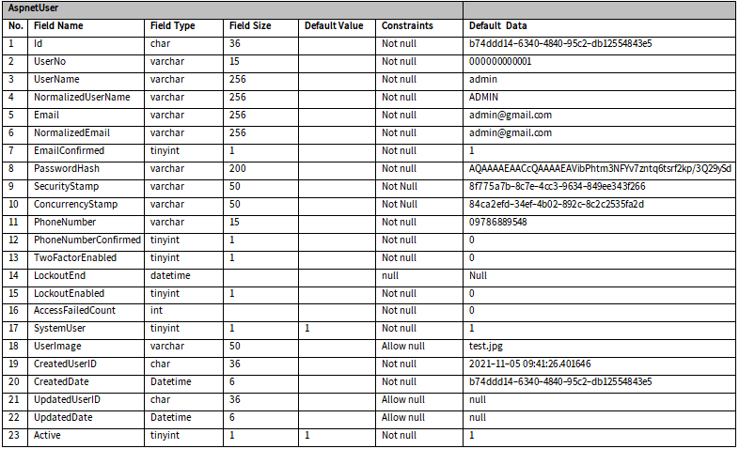

### Menu

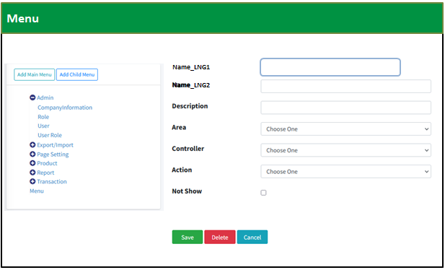

**Table Structure**

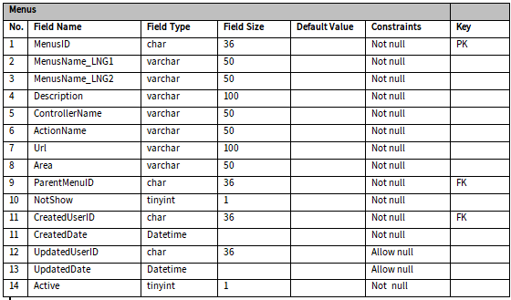

### Role

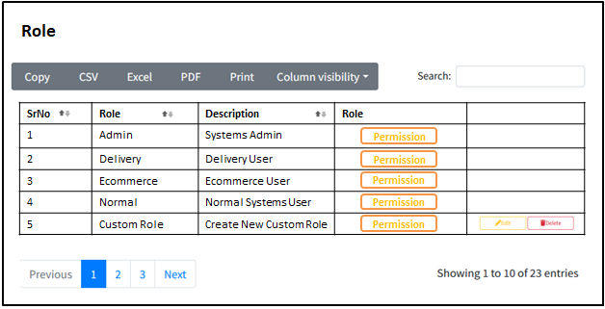

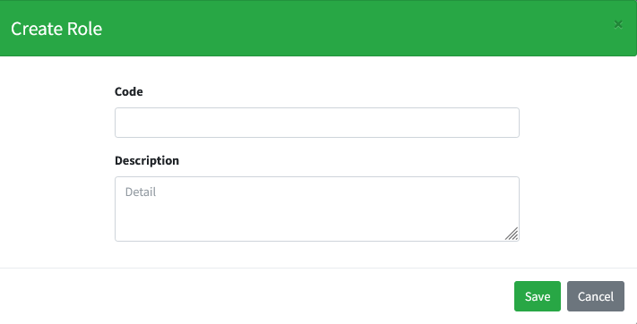

**Table Structure**

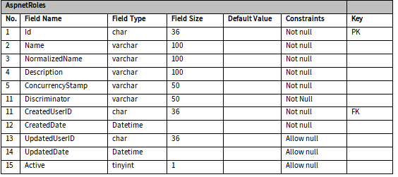

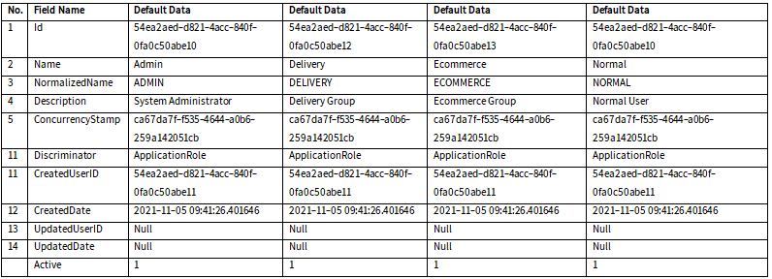

### Authorization

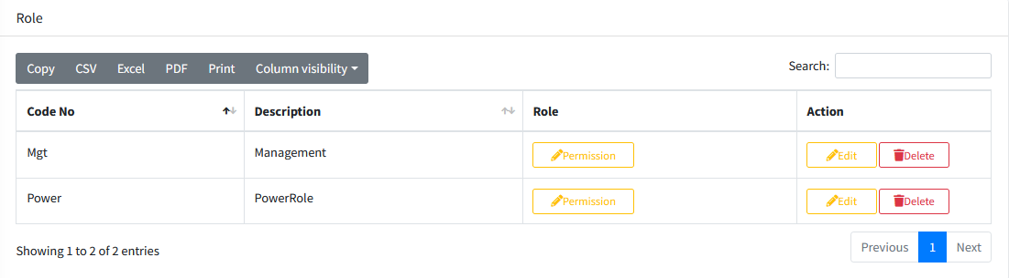

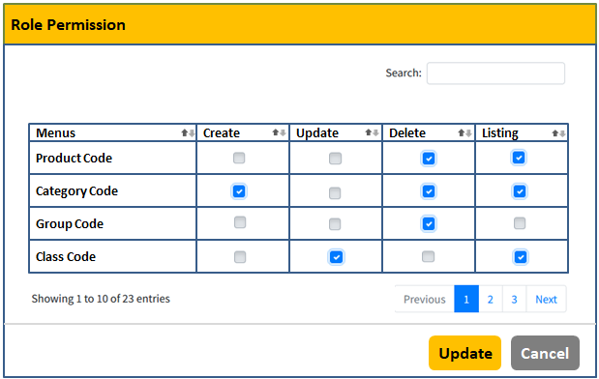

**Table Structure**

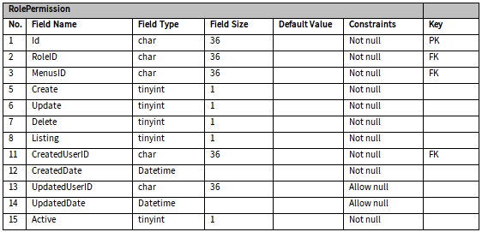

### Assign User Roles

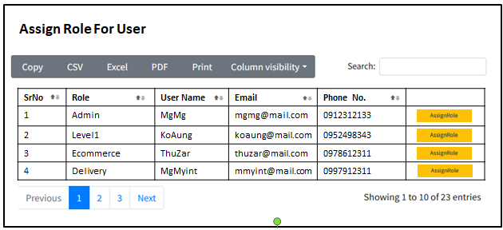

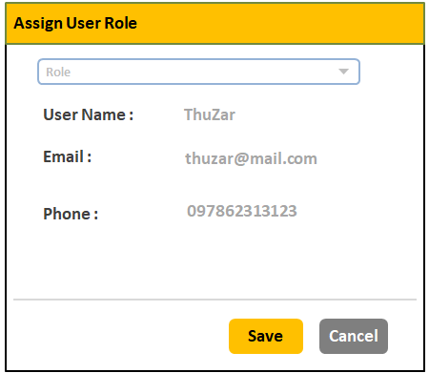

**Table Structure**

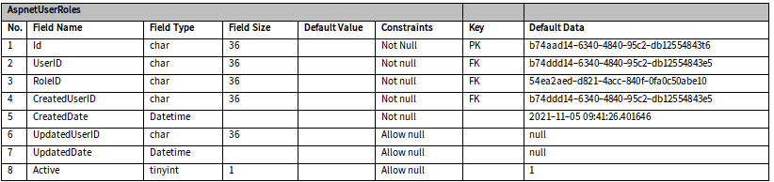

### Company Information

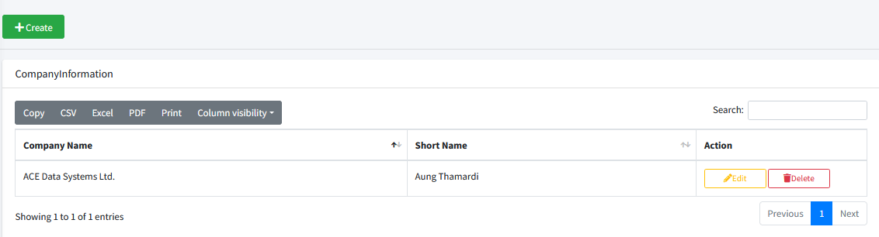

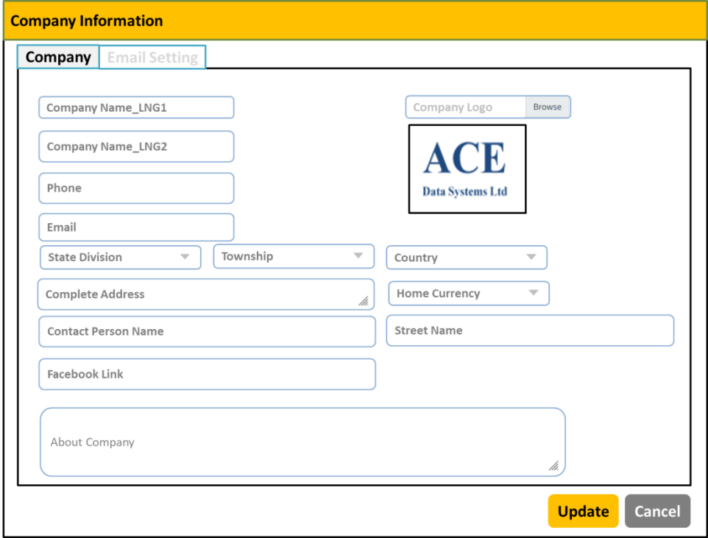

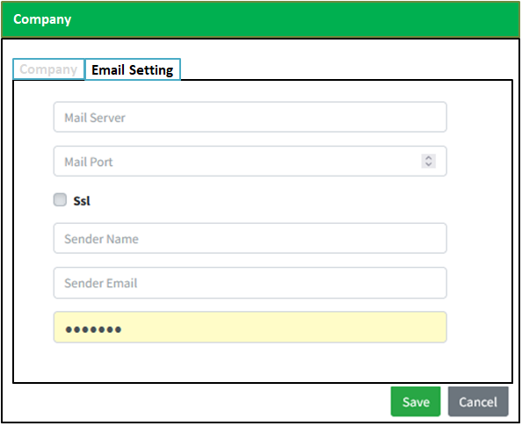

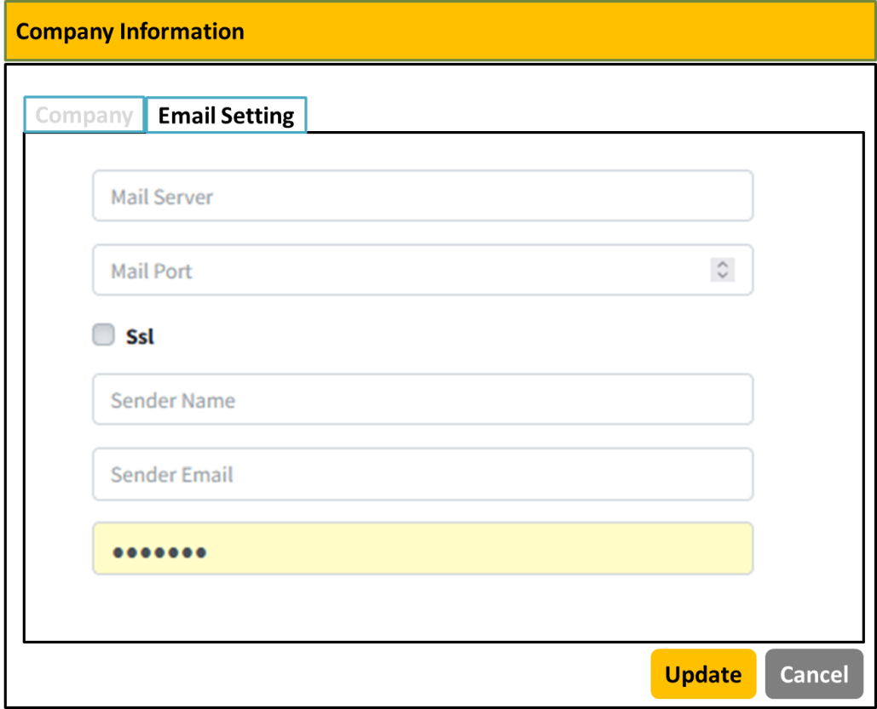

**Table Structure**

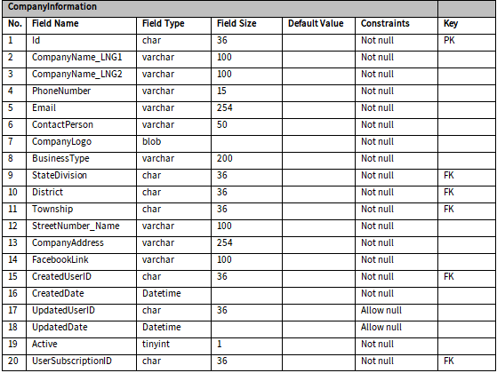

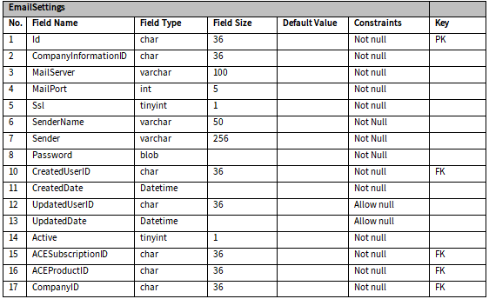

## Master Data Configuration

**Process Flow**

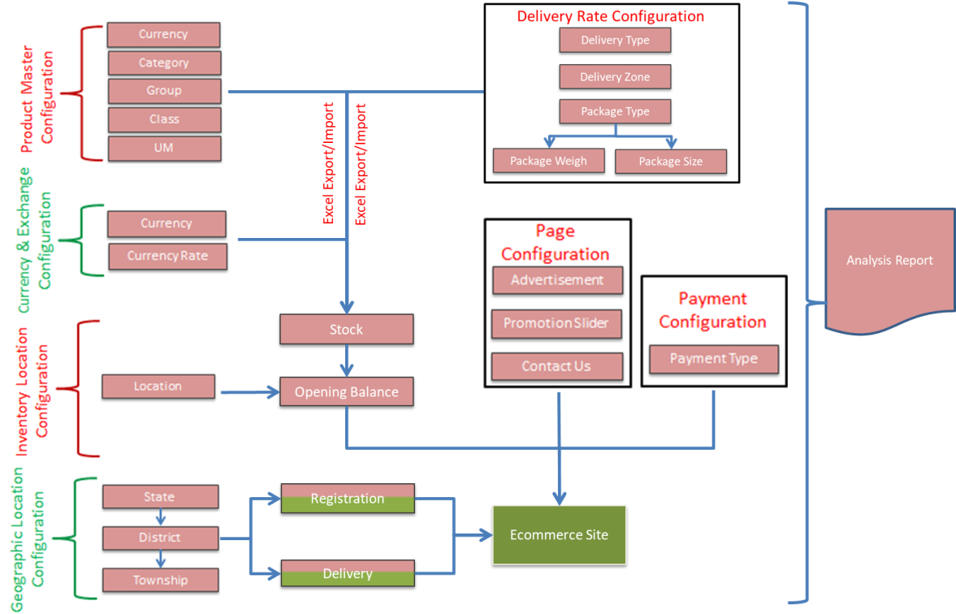

**Entity Relationship Diagram**

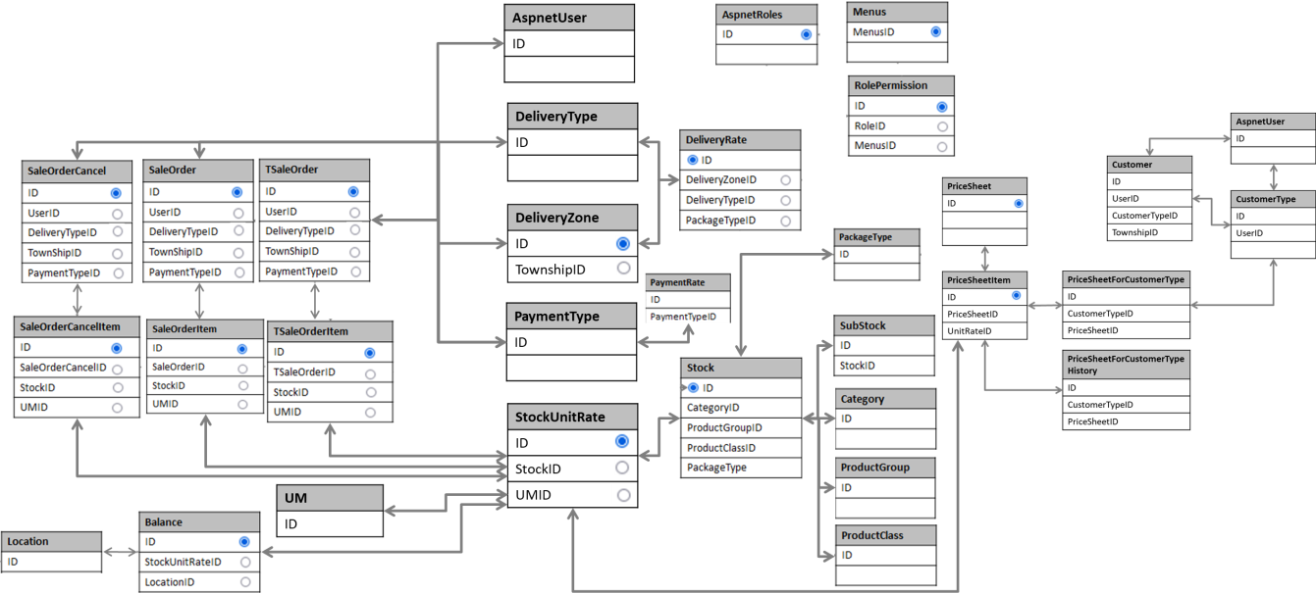

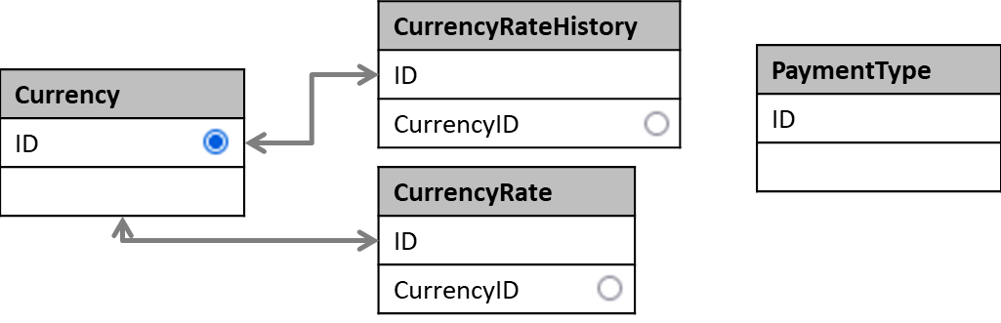

### Category

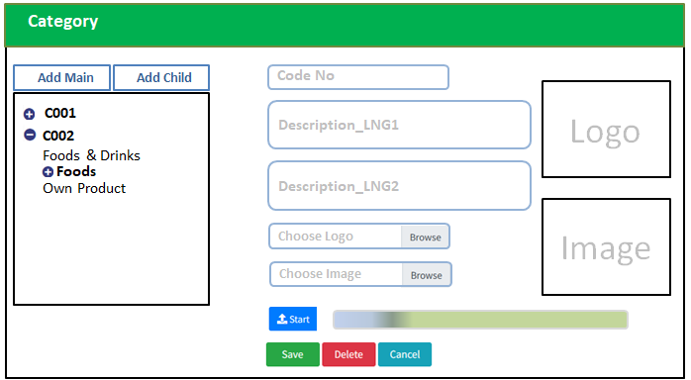

**Table Structure**

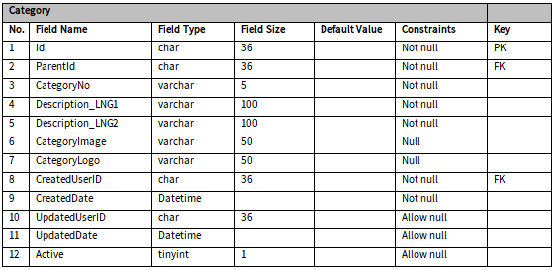

### Group

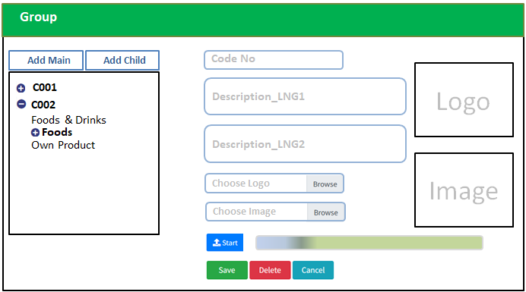

**Table Structure**

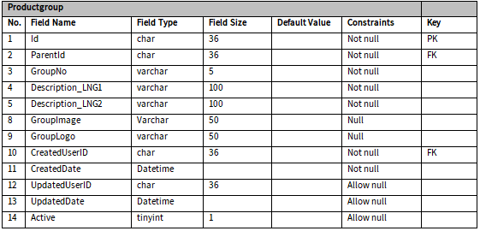

### Class

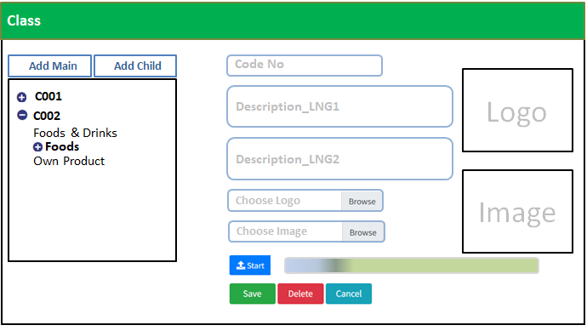

**Table Structure**

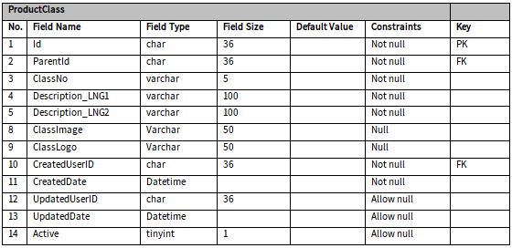

### UM (Unit of Measurement)

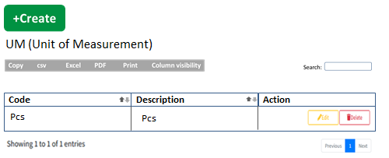

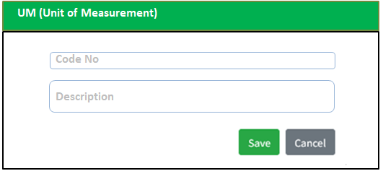

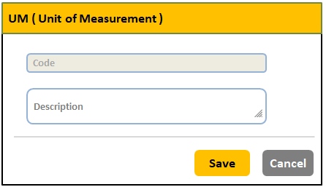

**Table Structure**

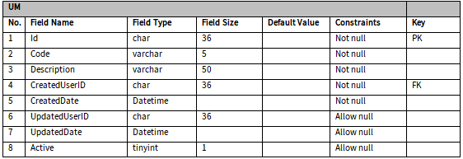

### Currency

1. There must be one default currency as “Home Currency”.
2. Don’t need to give permission to delete.
3. Must be disabled “Home Currency” check box.
4. Display data from “Currency” Table.
5. Insert all currency data into database from Internet or something.

**Entity Relationship Diagram**

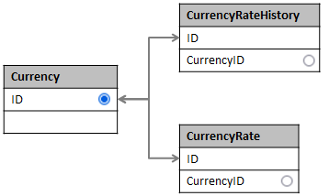

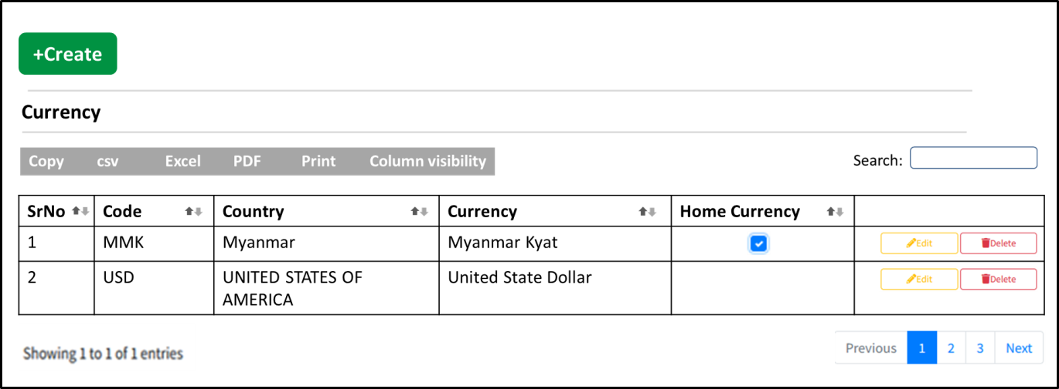

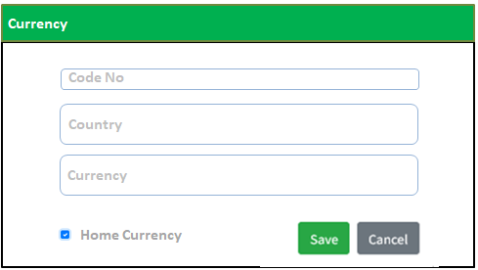

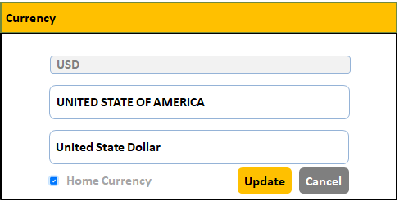

**Table Structure**

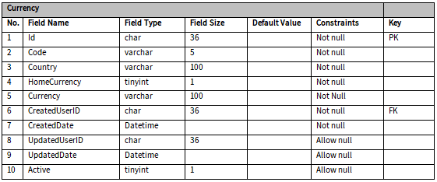

### Currency Rate

**Process Flow**

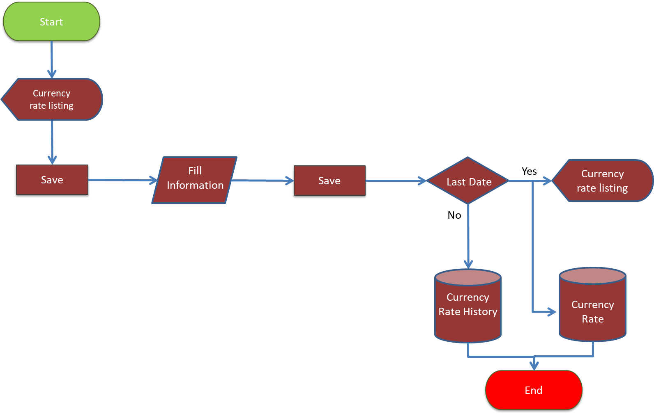

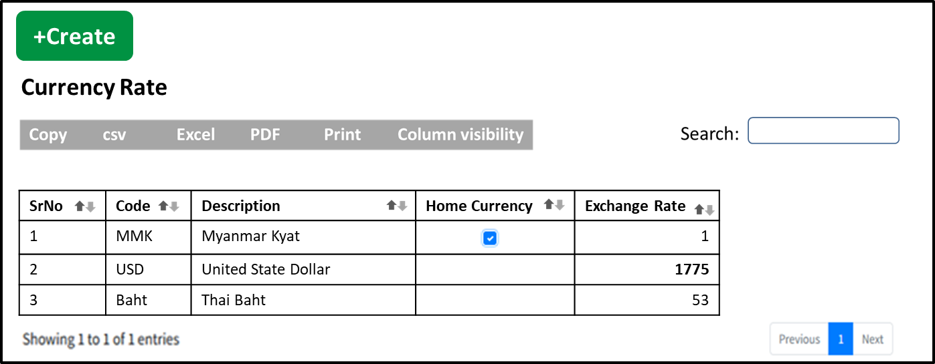

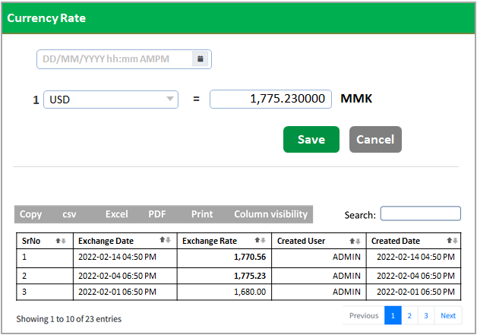

**Table Structure**

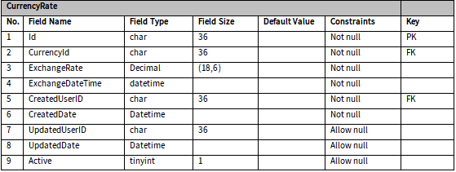

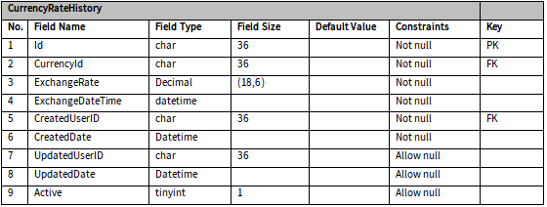

### State, District, Township

Migration Data

### Package Type

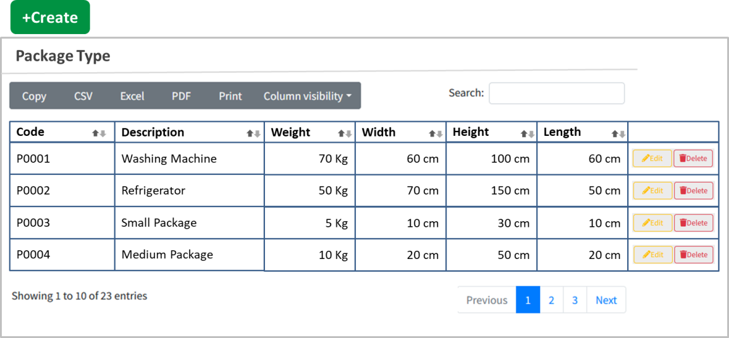

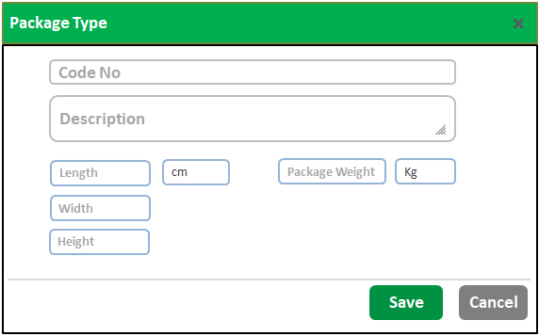

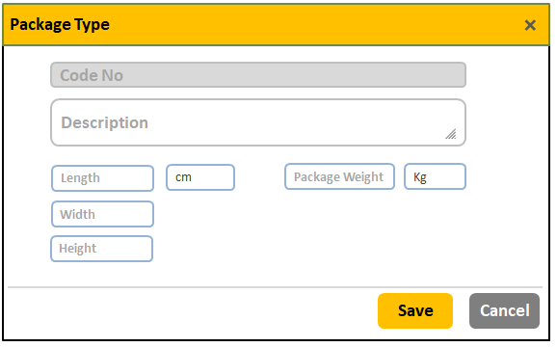

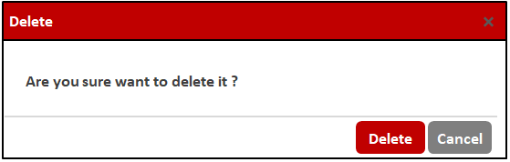

**Table Structure**

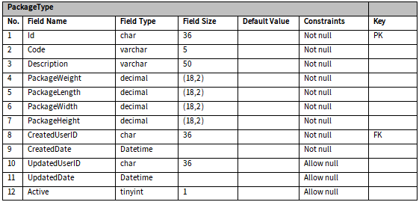

### Delivery Type

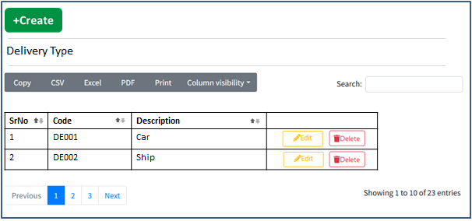

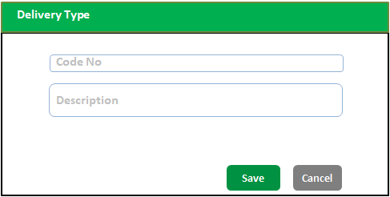

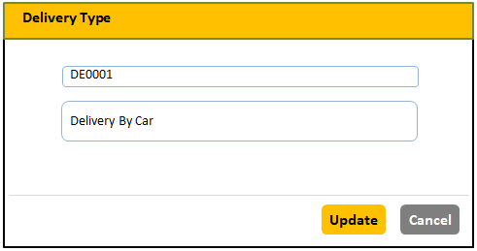



**Table Structure**

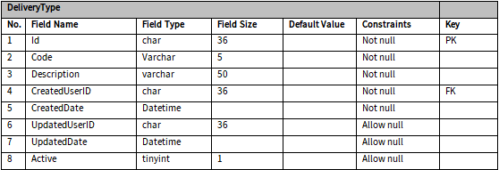

### Delivery Zone

**Entity Relationship Diagram**

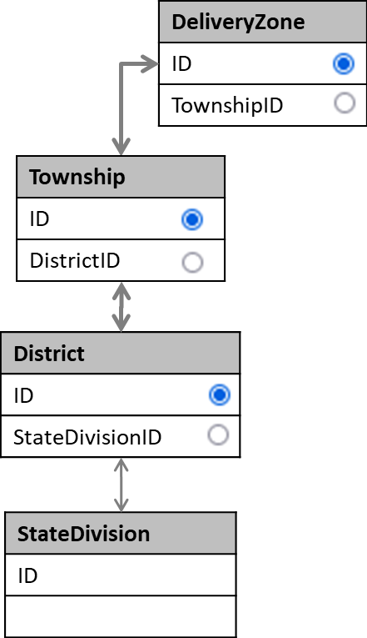

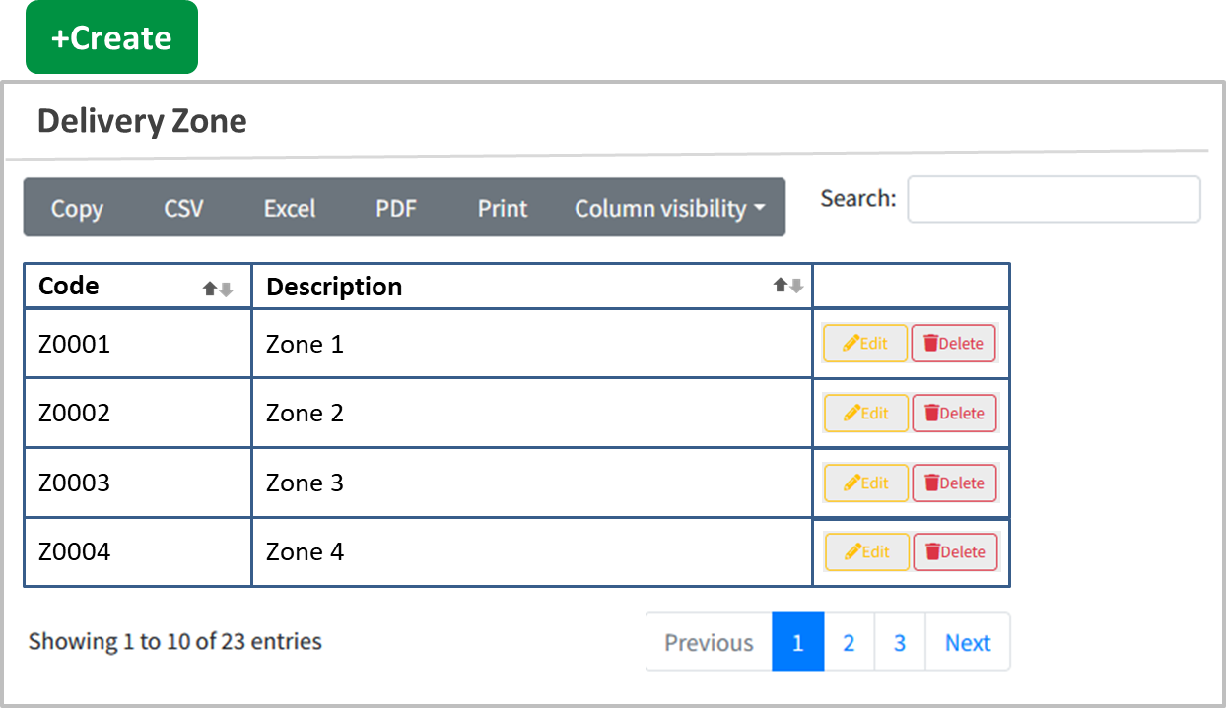

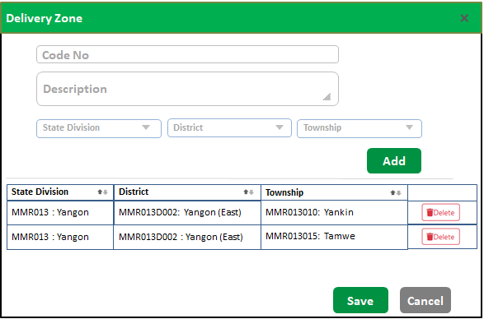

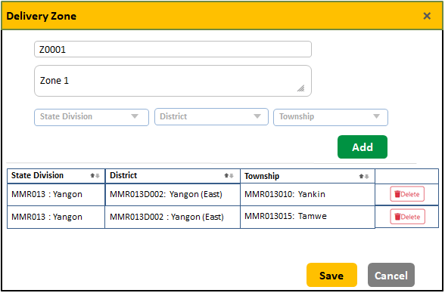



**Table Structure**

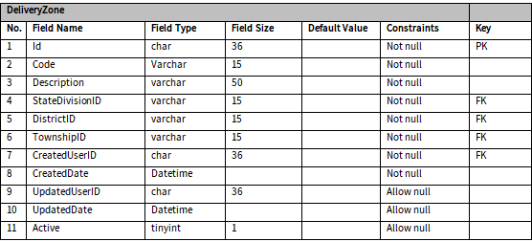

### Delivery Rate

**Entity Relationship Diagram**

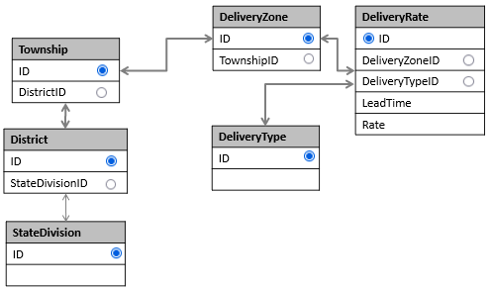

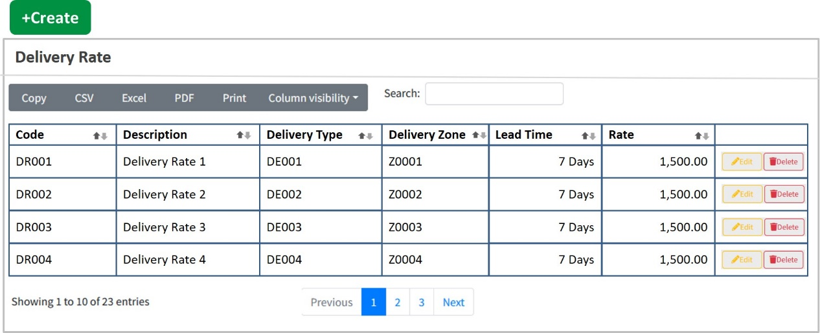

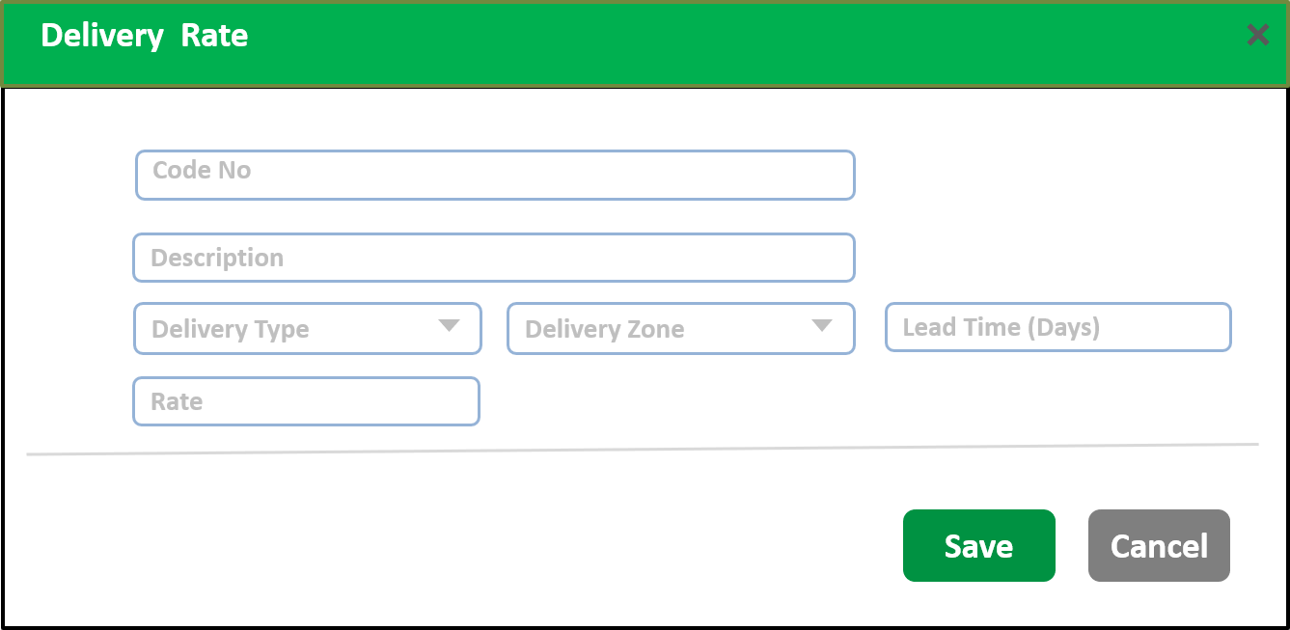

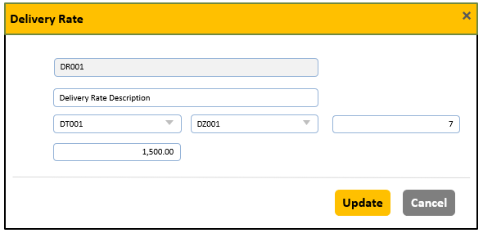



**Table Structure**

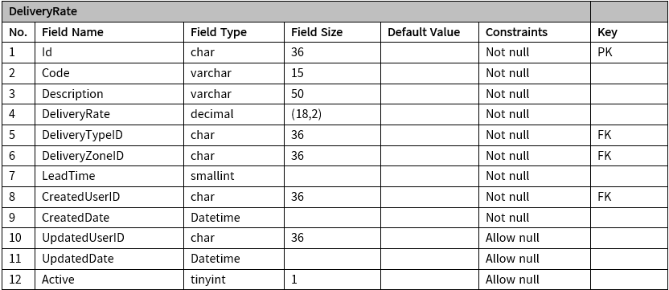

### Payment Type

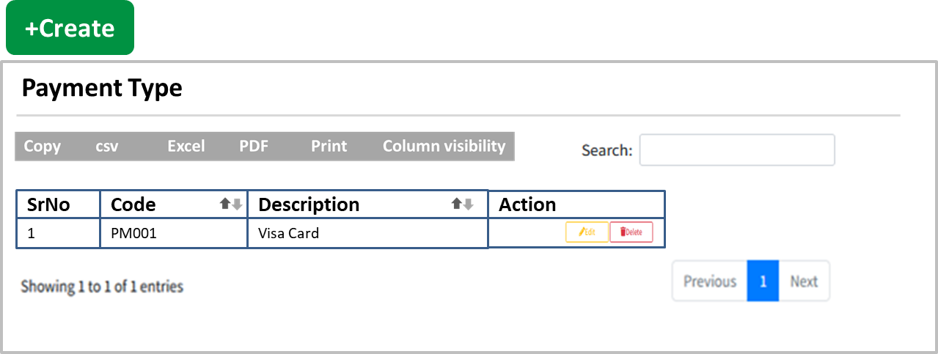

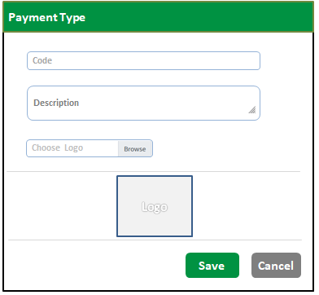

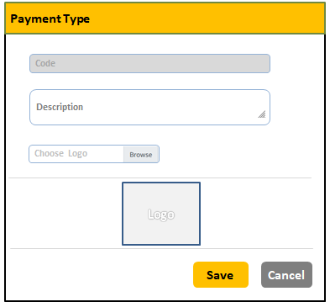



**Table Structure**

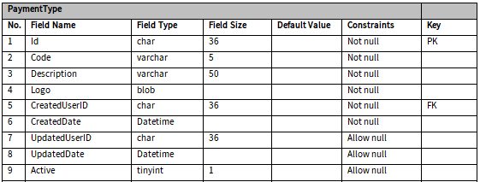

### Payment Rate

**Entity Relationship Diagram**

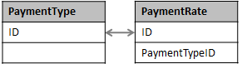

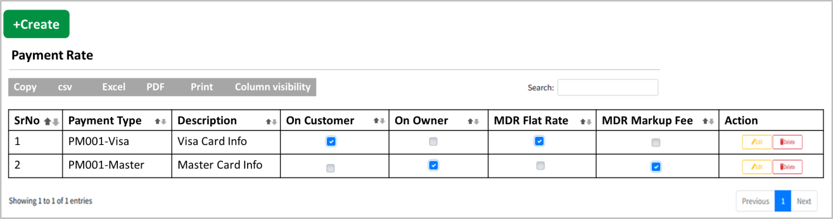

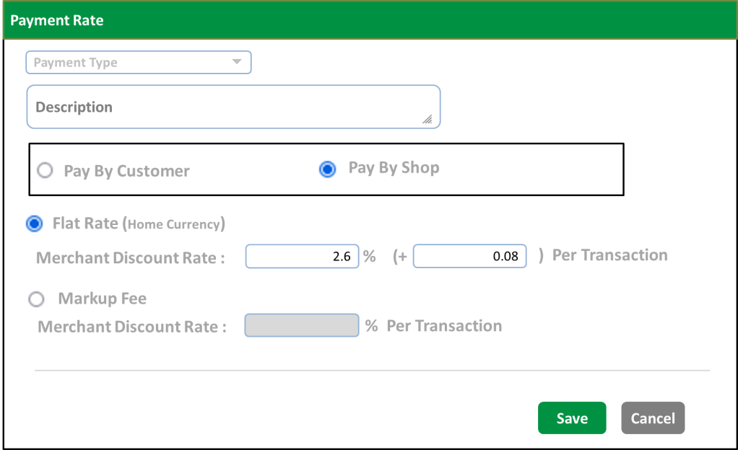

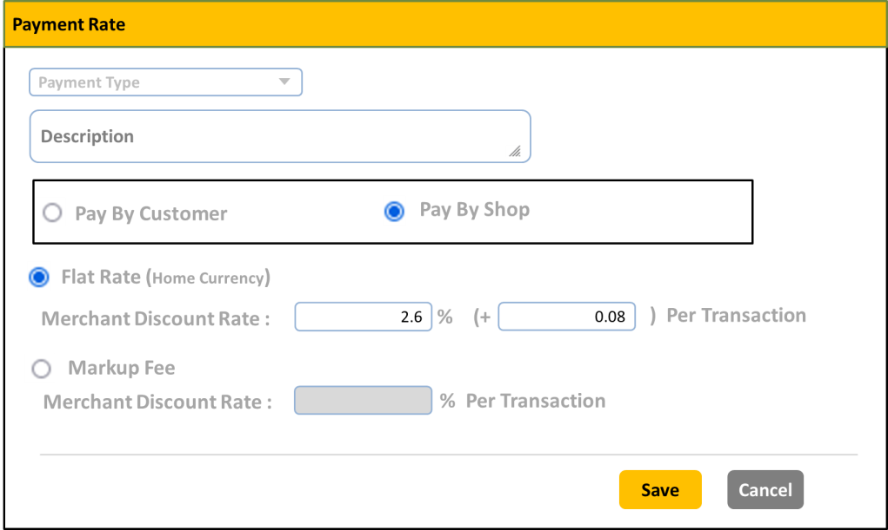



**Table Structure**

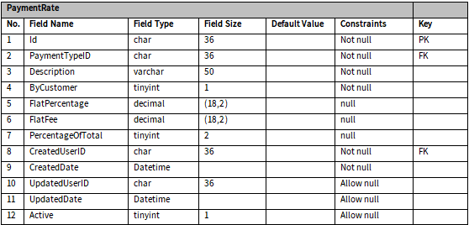

### Product Code Setup

**Process Flow**

* **Stock Entry Process**

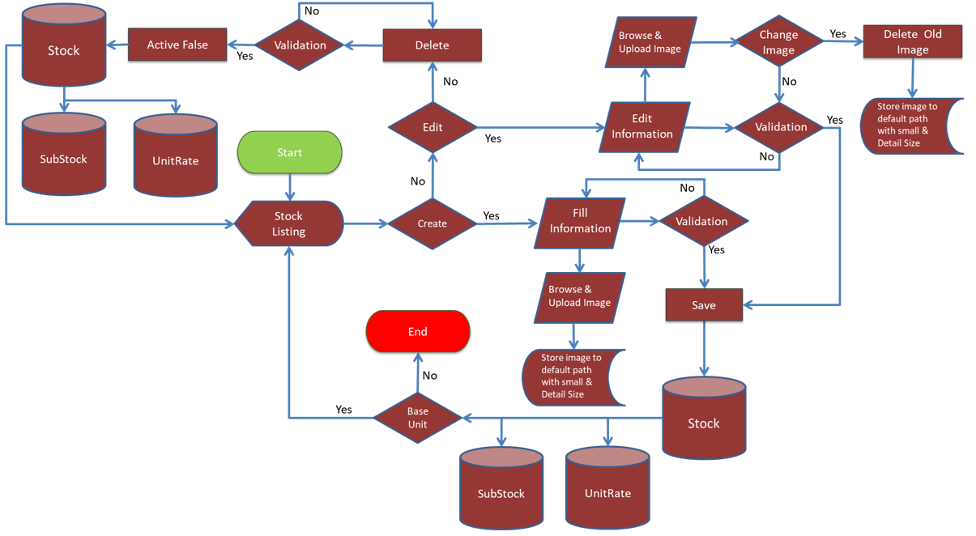

* **Go To Unit Rate From Stock Process**

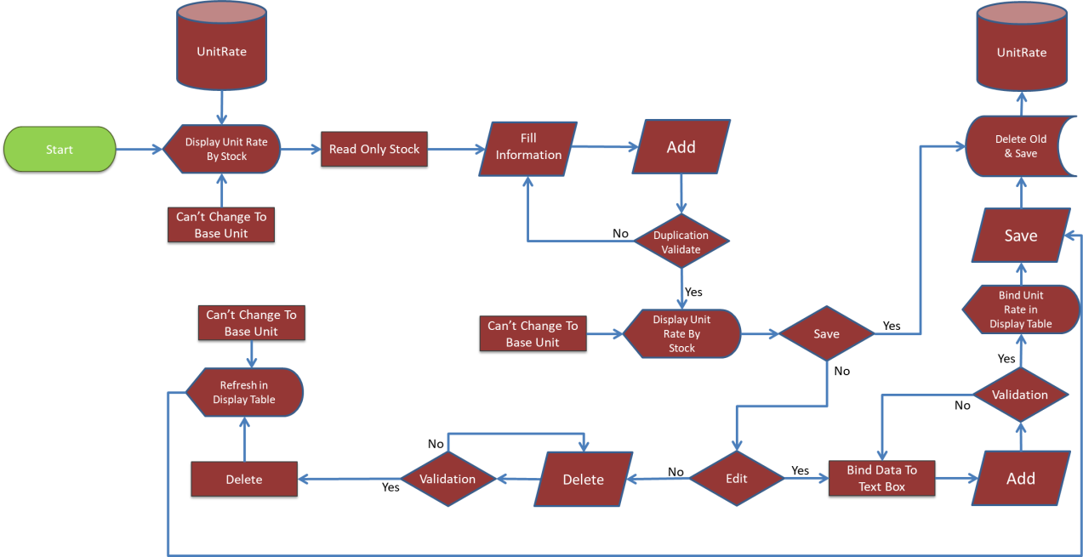

**Entity Relationship Diagram**

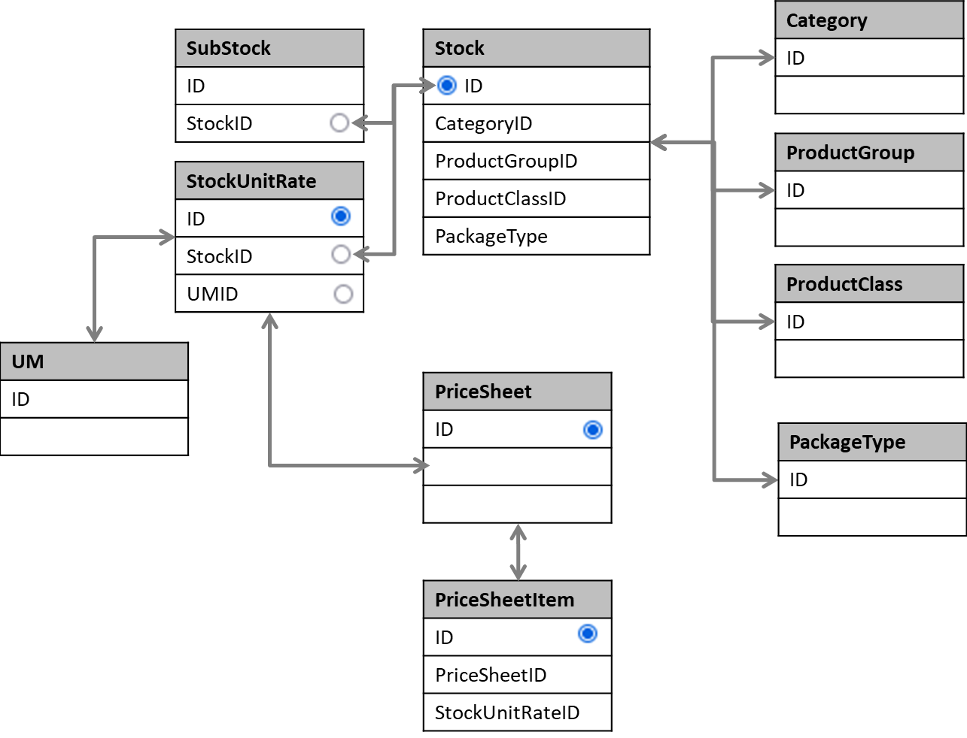

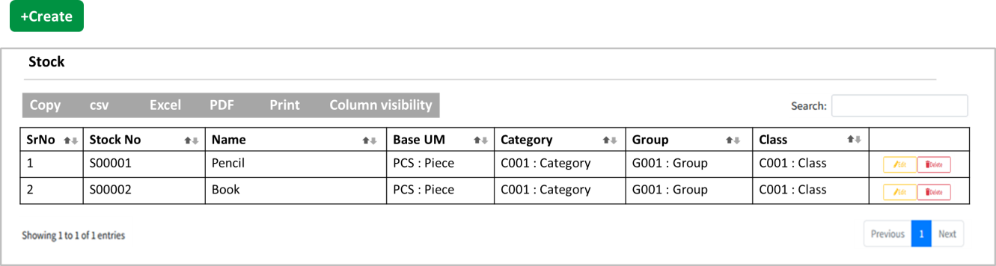

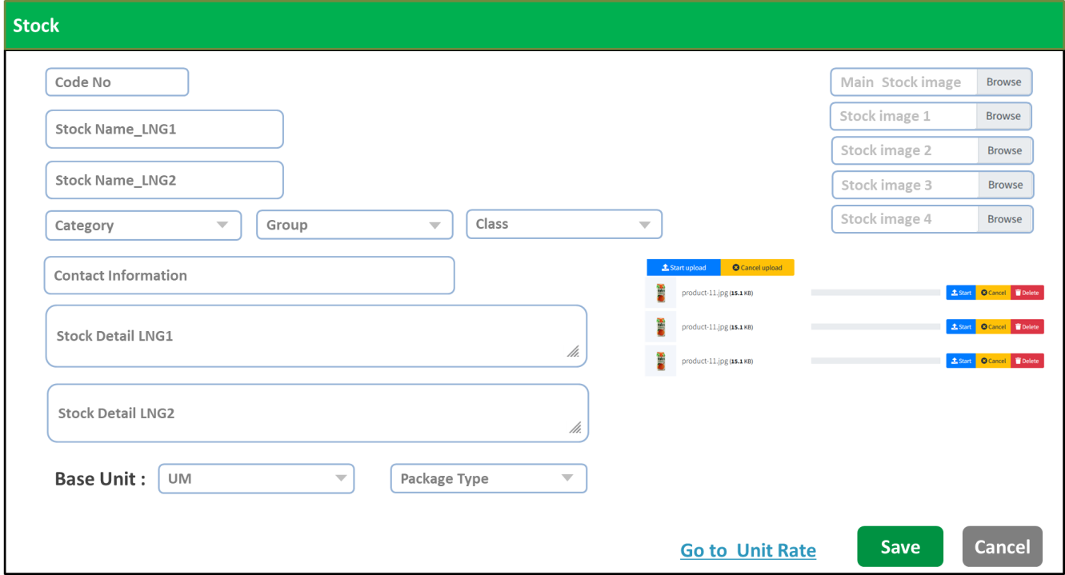

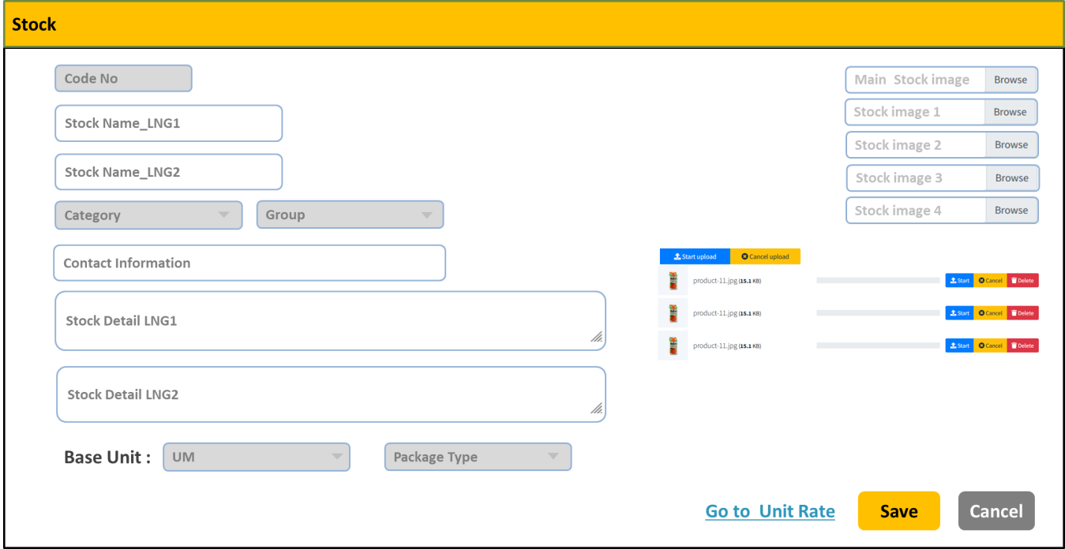

**Table Structure**

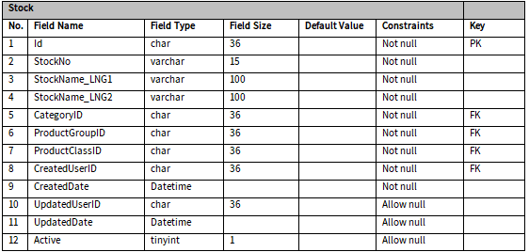

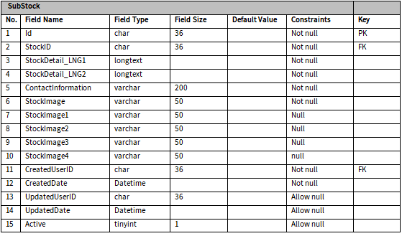

### Unit Rate

**Process Flow**

* **Unit Rate Process**

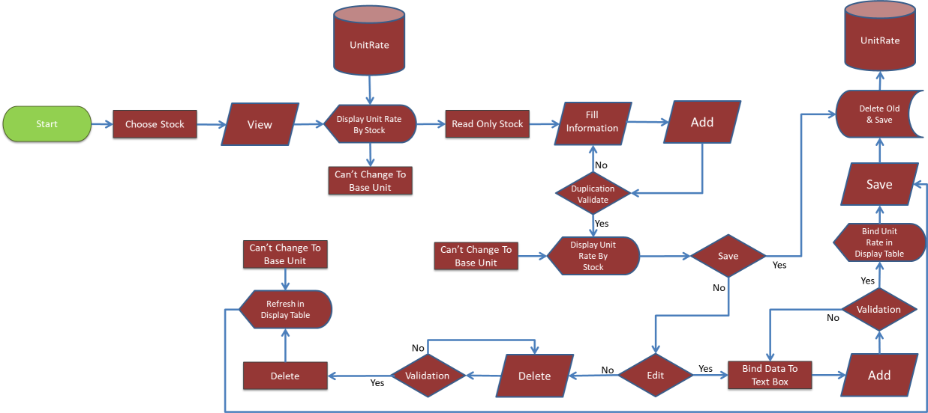

* **Go To Price Sheet from Unit Rate Process**

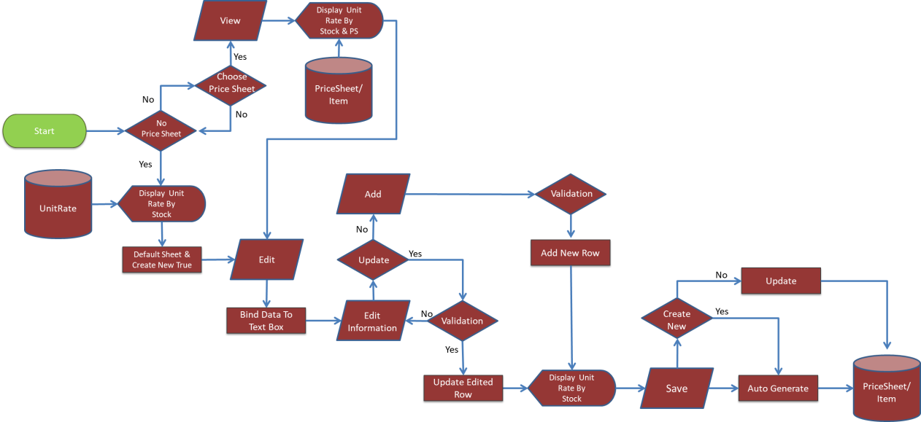

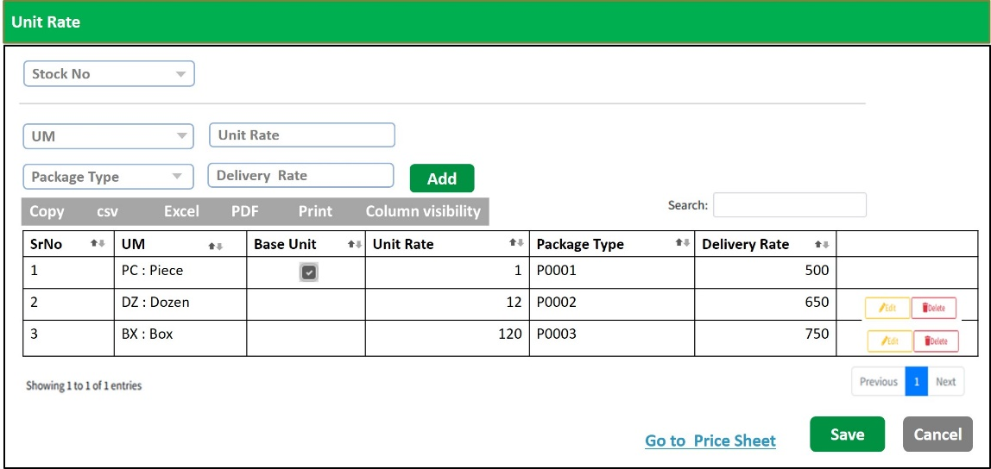

**Table Structure**

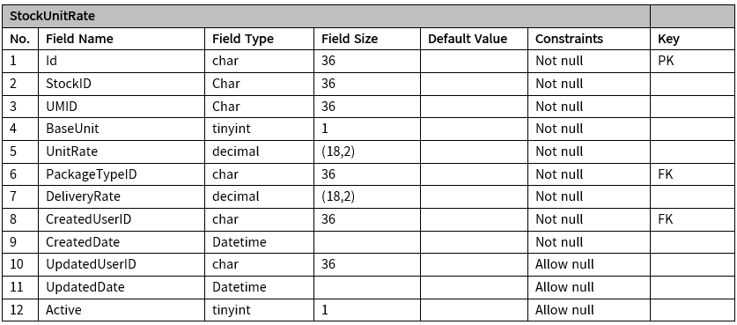

### Price Sheet Setup

**Process Flow**

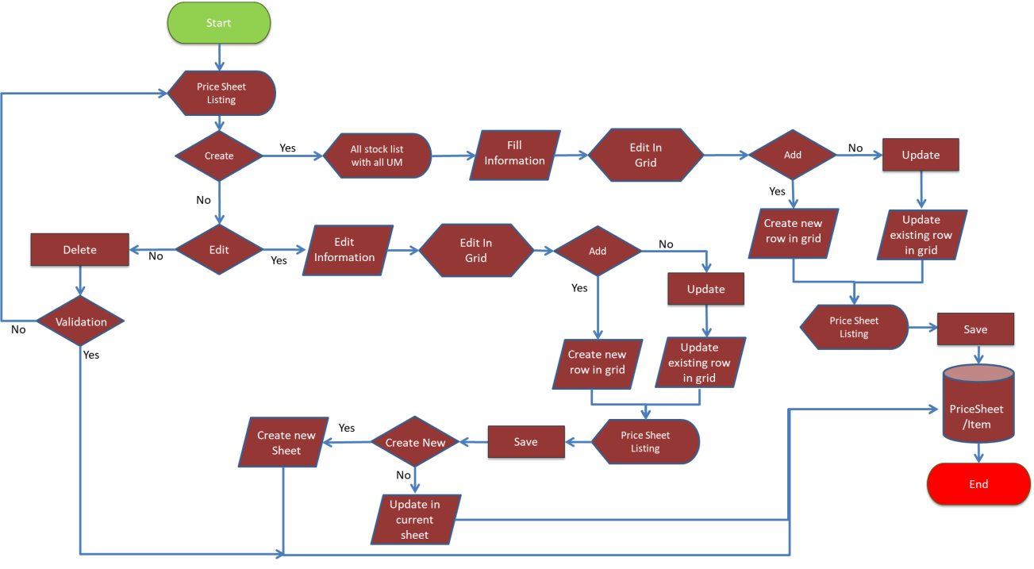

**Entity Relationship Diagram**

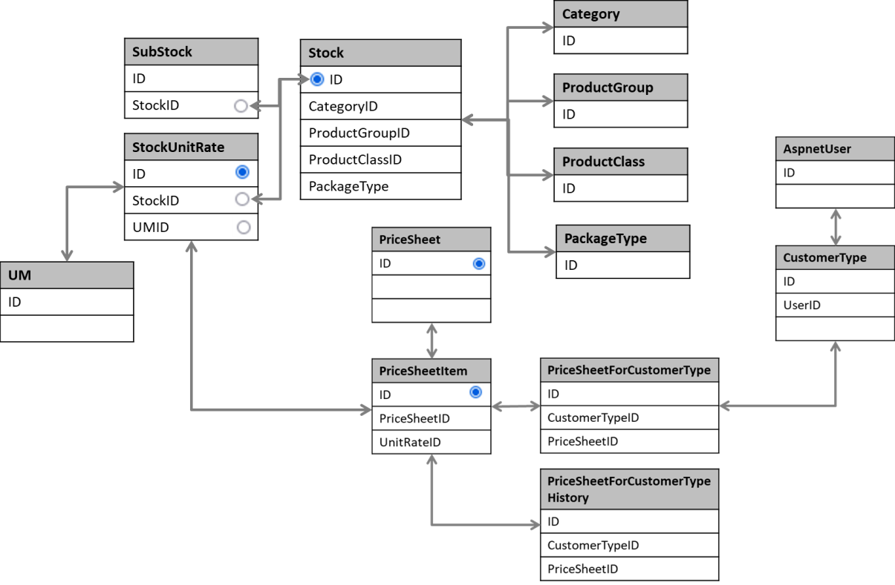

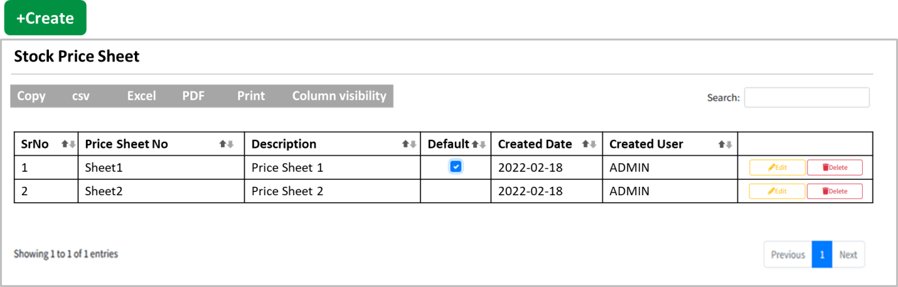

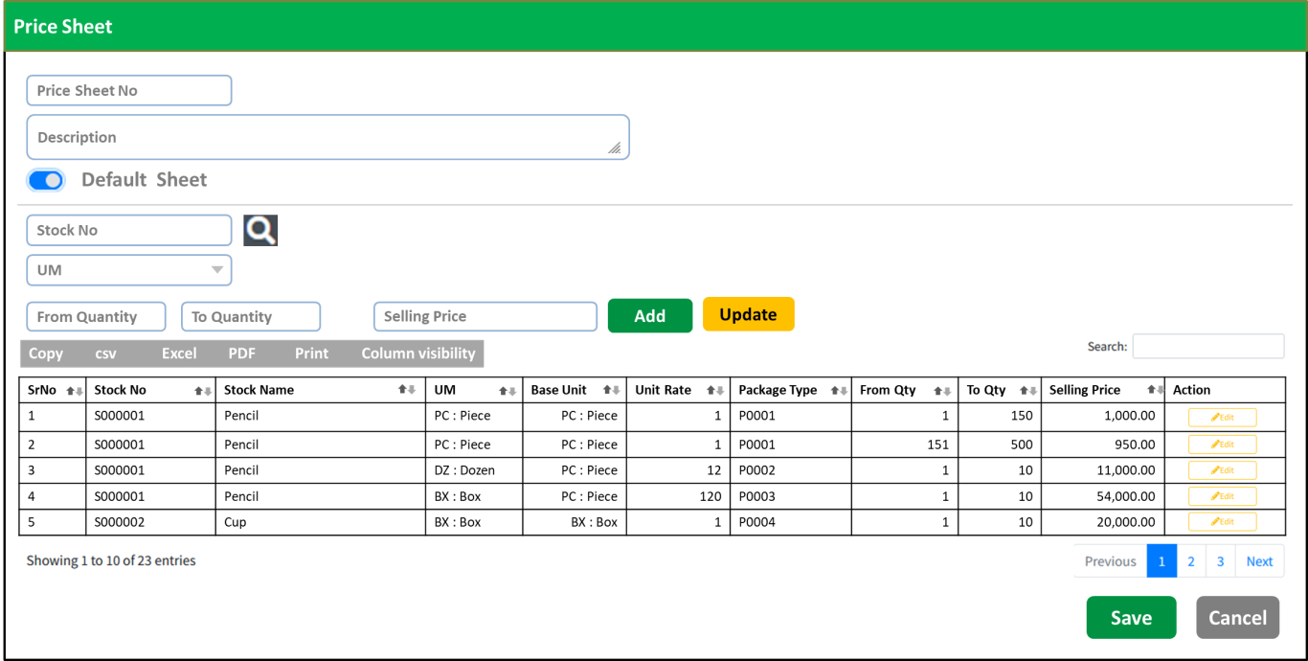

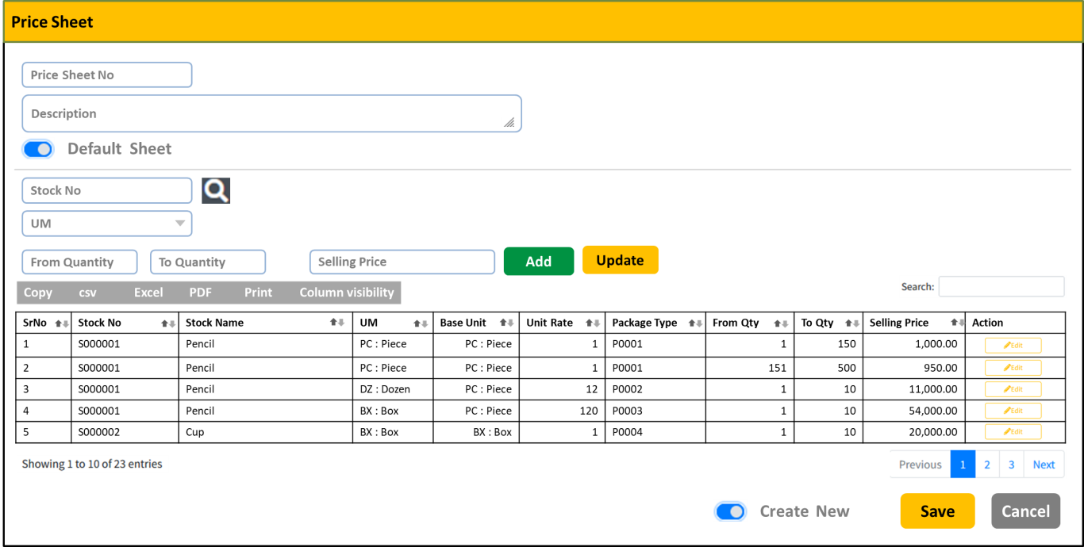

**Table Structure**

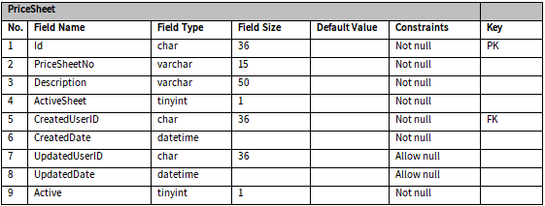

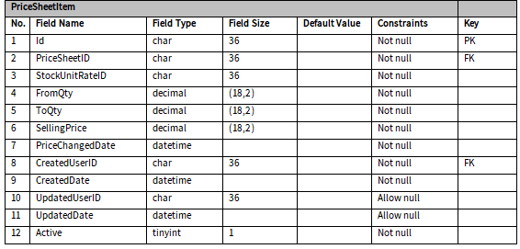

### Inventory Location

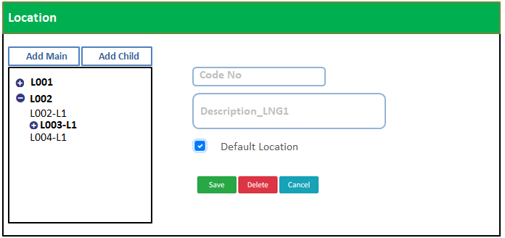

**Table Structure**

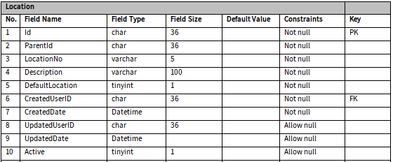

### Opening Balance

**Process Flow**

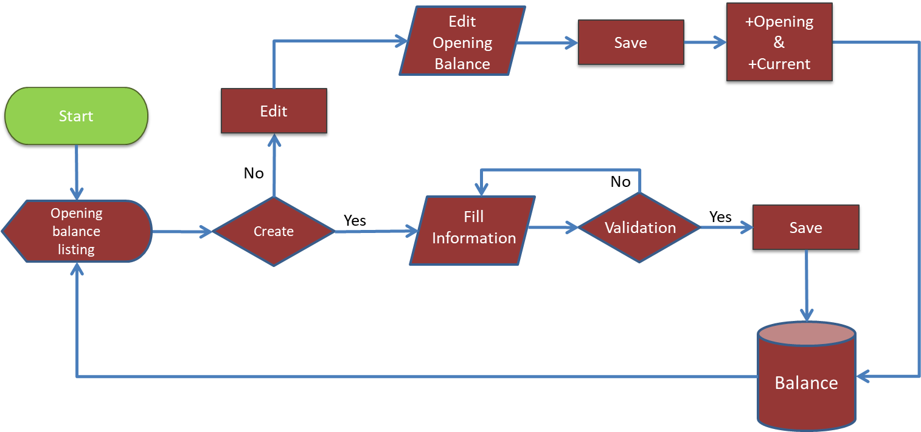

**Entity Relationship Diagram**

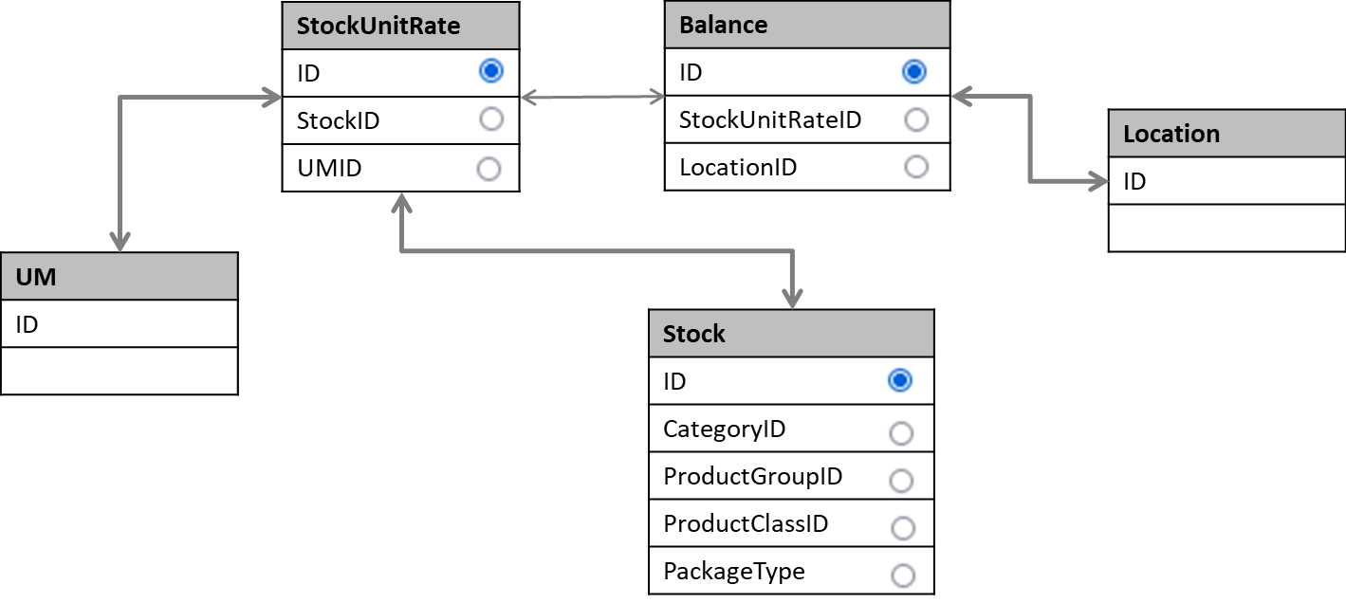

User Interface

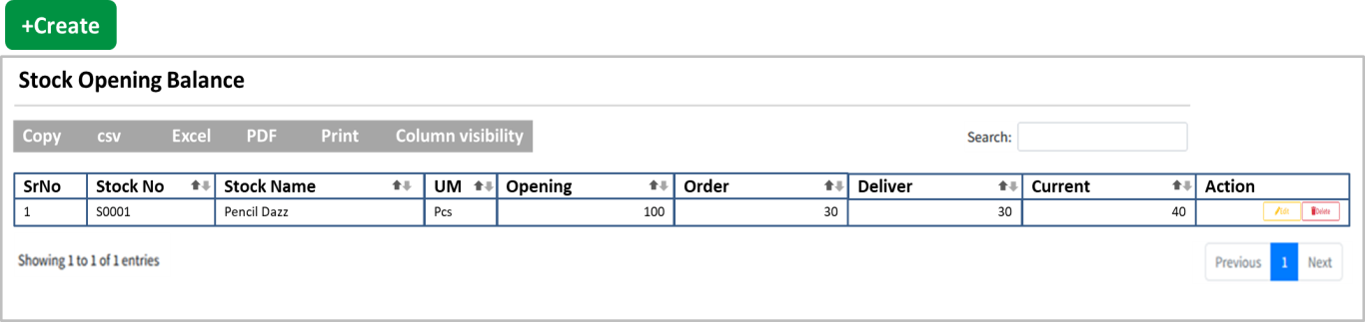

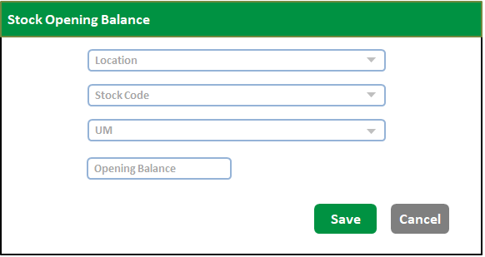

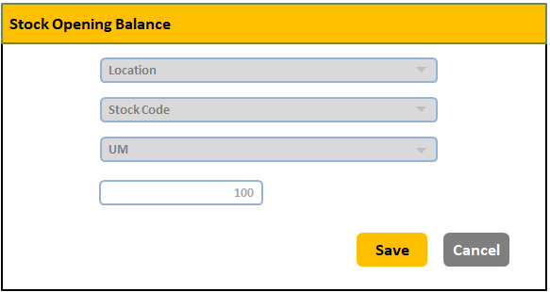

**Table Structure**

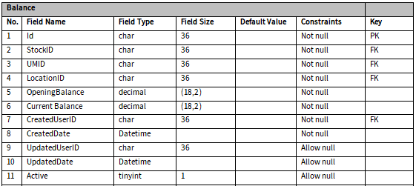

### Customer Type

**Entity Relationship Diagram**

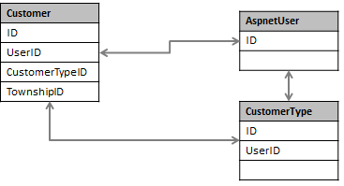

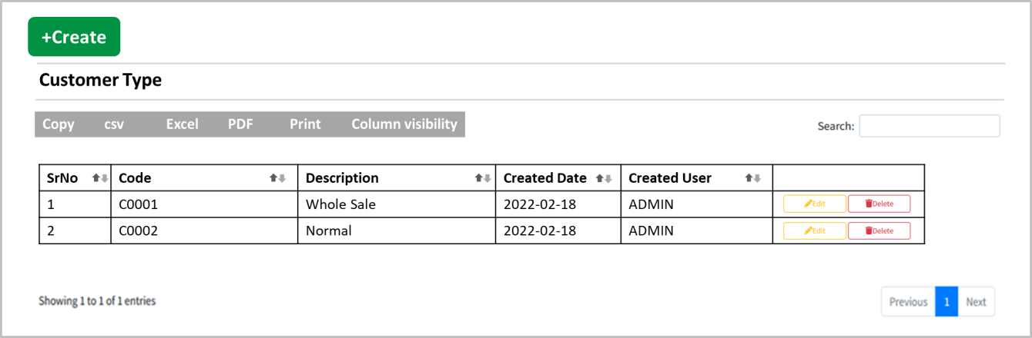

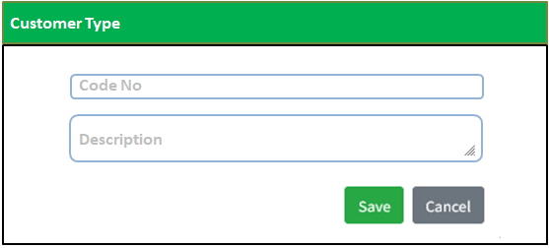

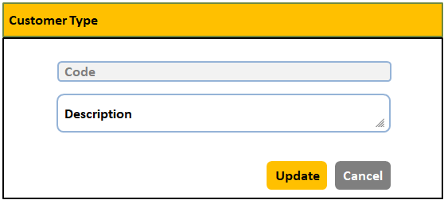

**Table Structure**

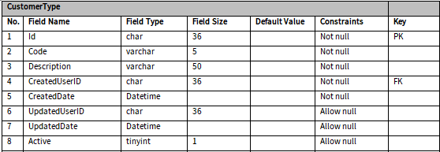

### Customer

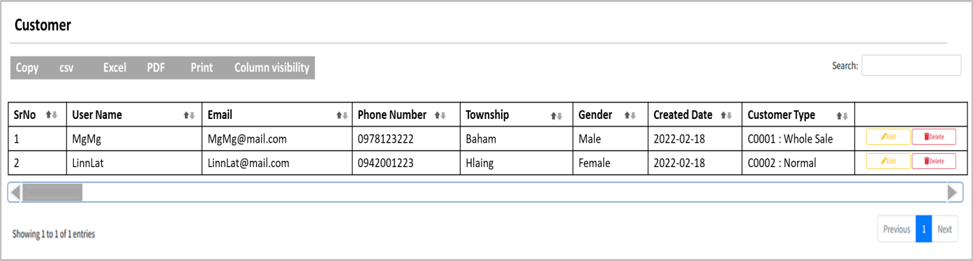

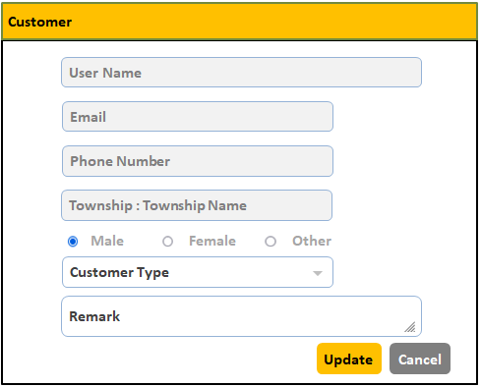

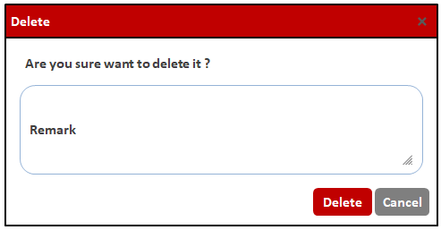

**Table Structure**

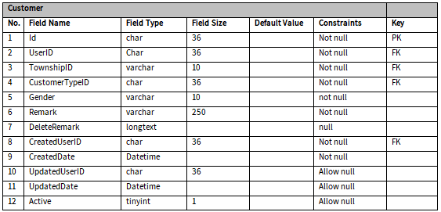

### Price Sheet for Customer Type

**Process Flow**

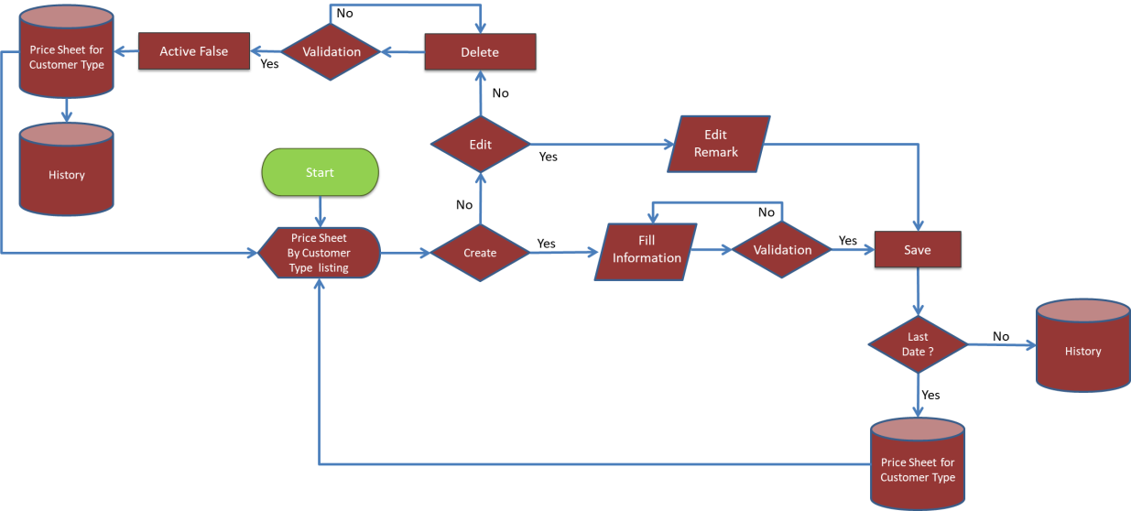

**Entity Relationship Diagram**

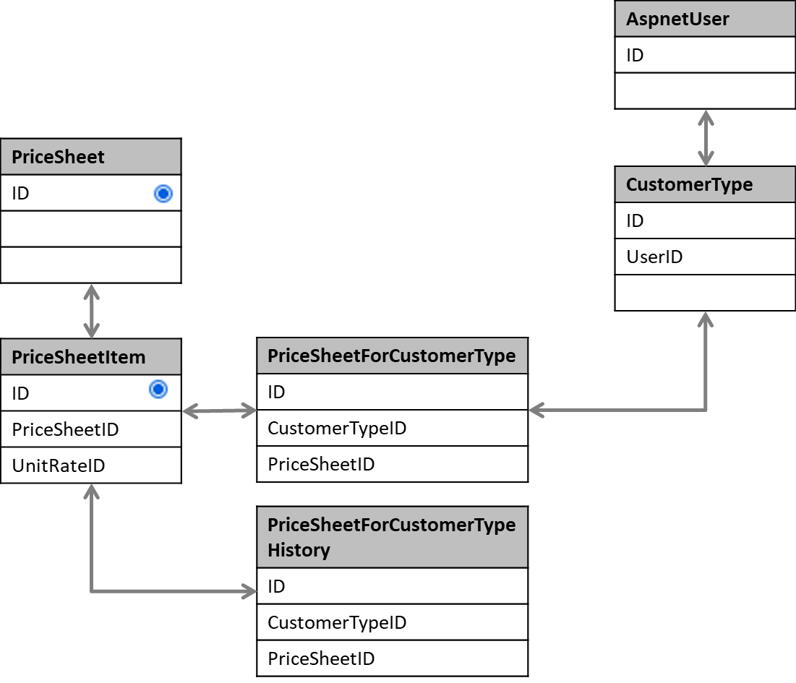

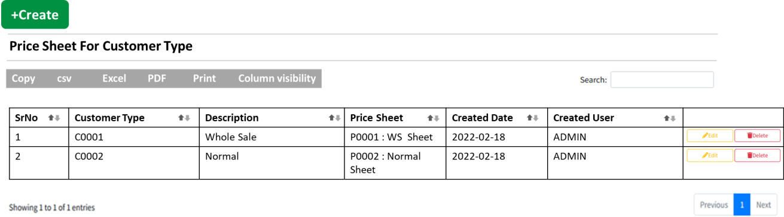

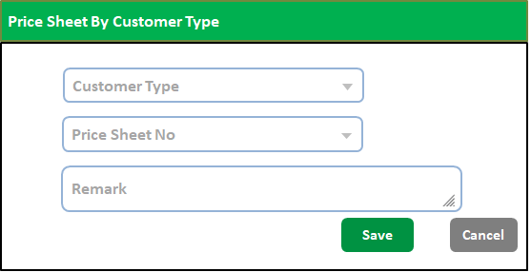

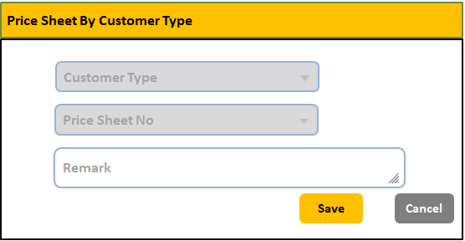

**Table Structure**

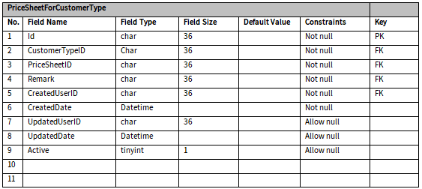

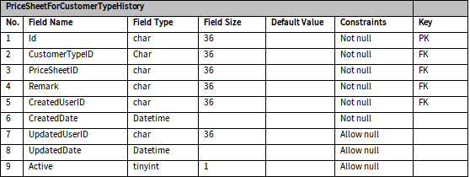

### Main Code Import

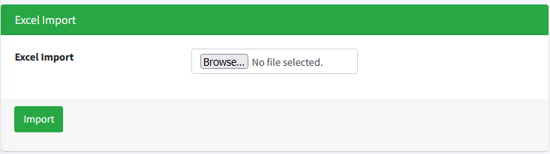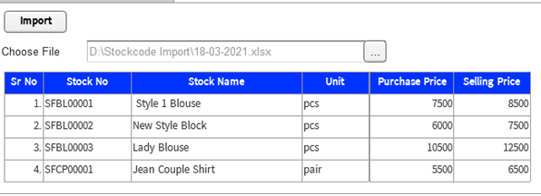

### Main Code Export

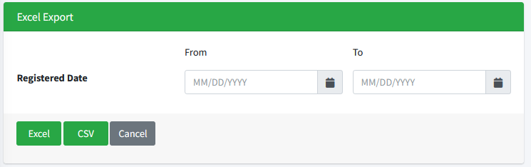

## Page Setting Module

### Advertisement

**Process Flow**

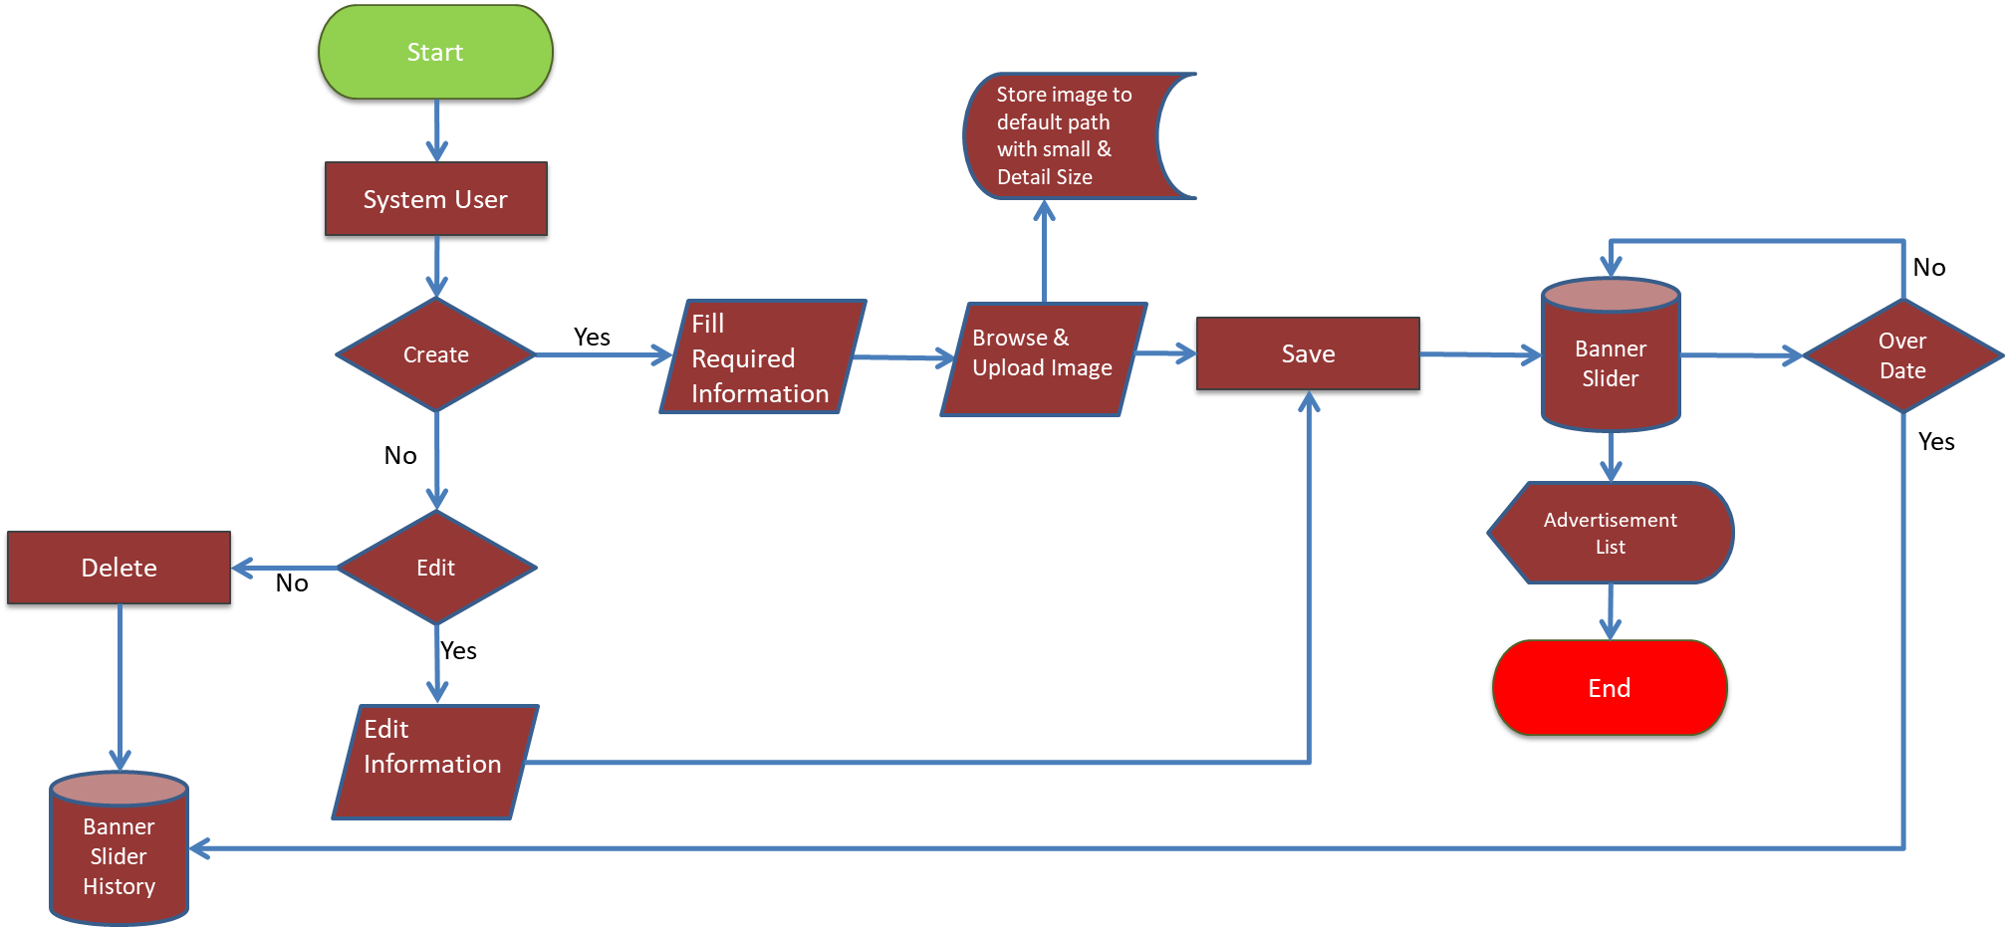

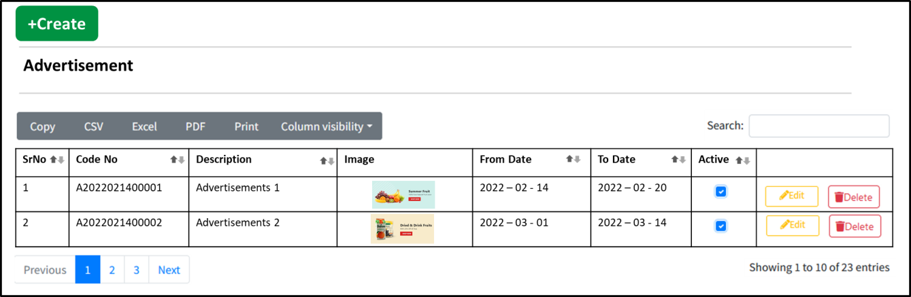

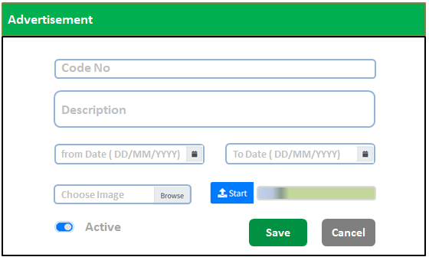

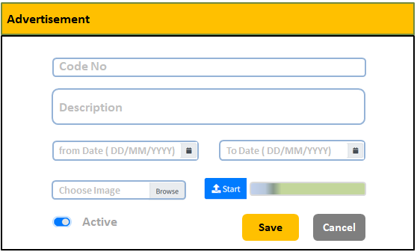

**Table Structure**

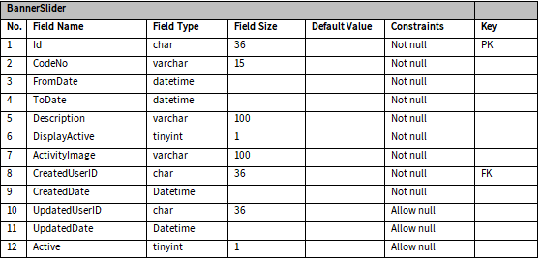

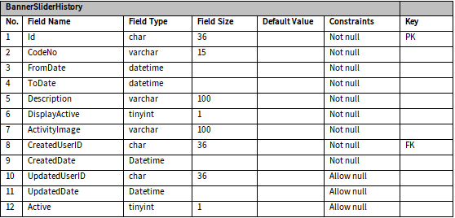

### Contact Us

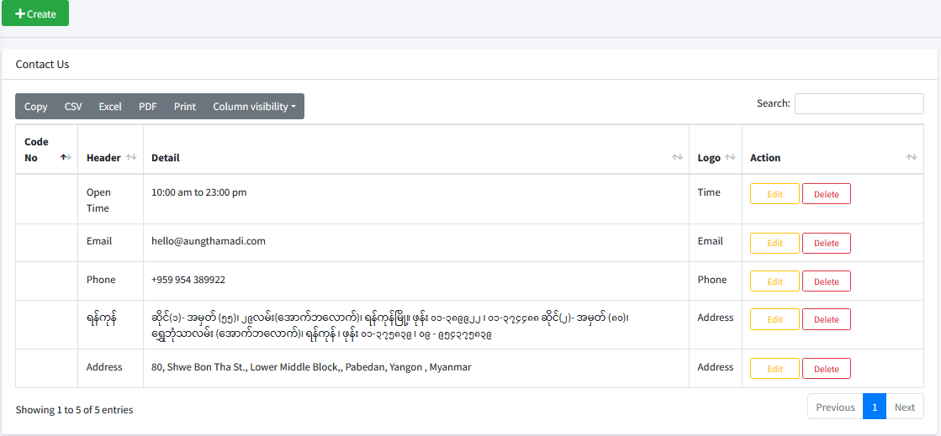

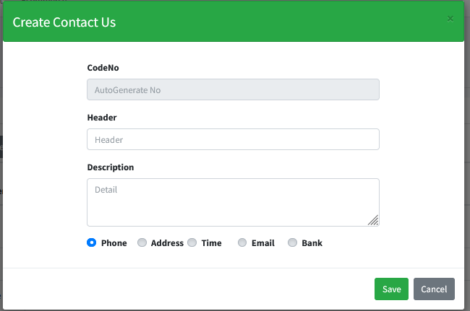

**Table Structure**

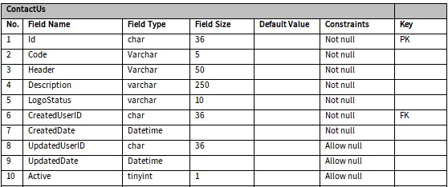

### Privacy & Policy

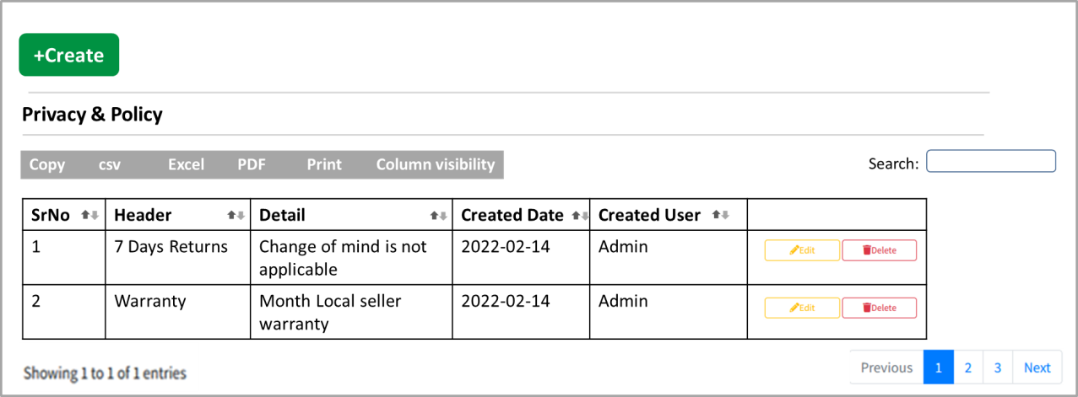

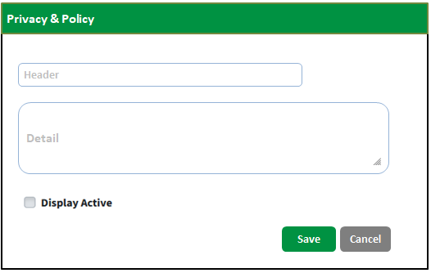

**Table Structure**

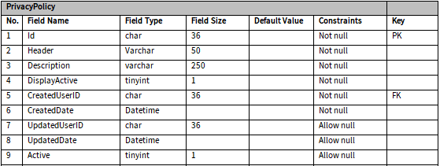

## Sale Module

**Process Flow**

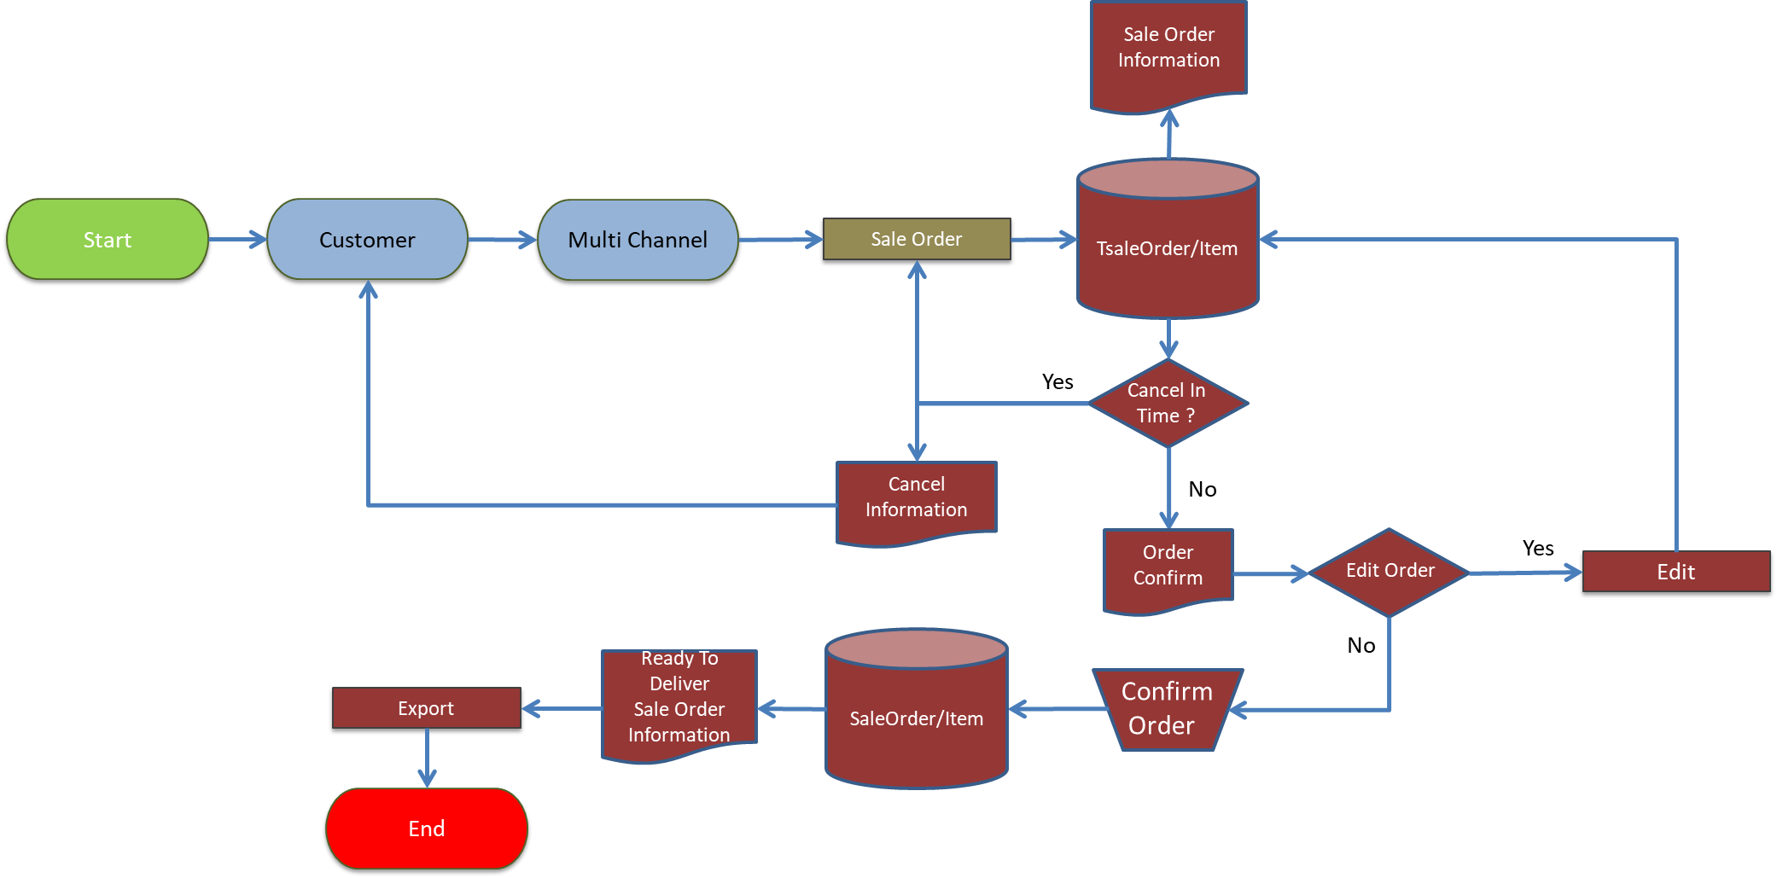

**Entity Relationship Diagram**

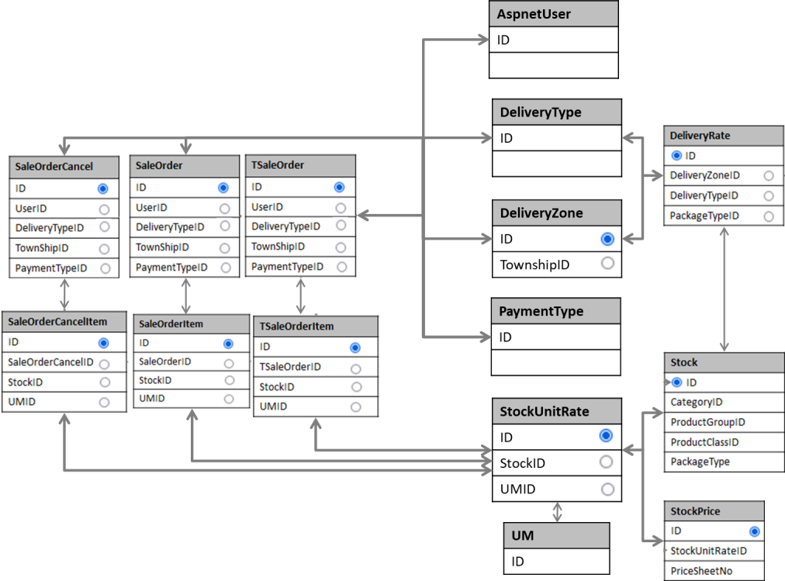

### Sale Order Edit

**Process Flow**

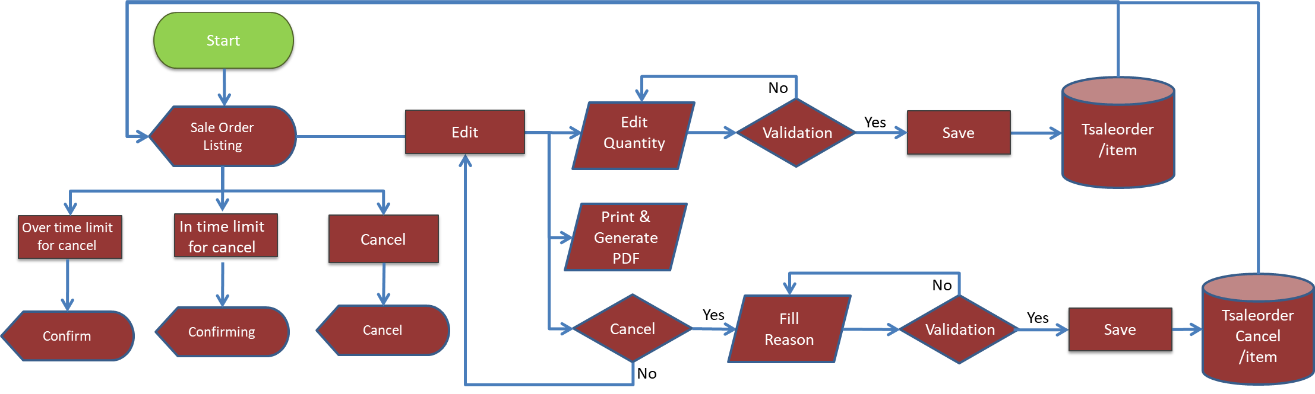

**\*Balance Check Flow**



**Entity Relationship Diagram**

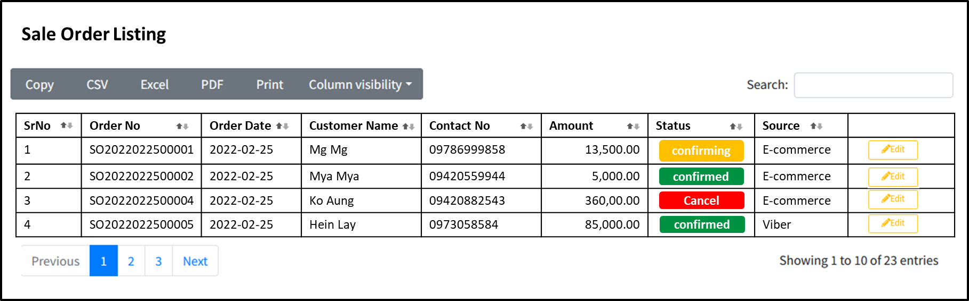

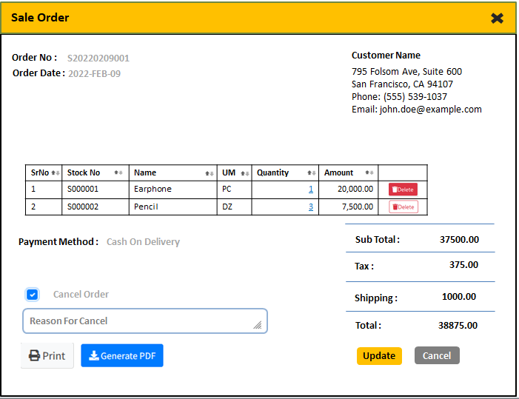

**Table Structure**

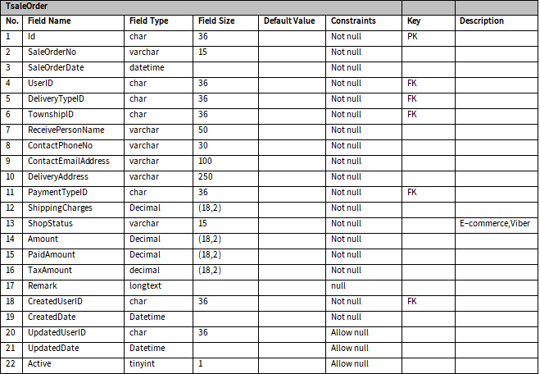

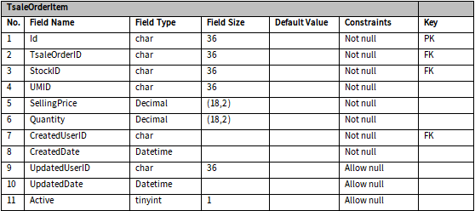

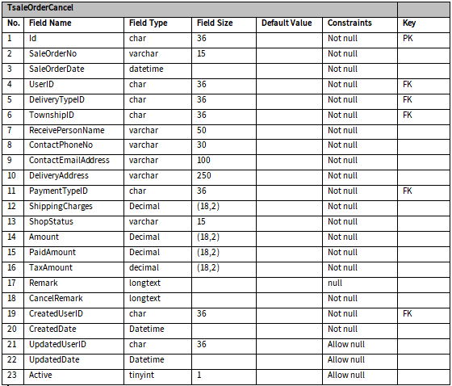

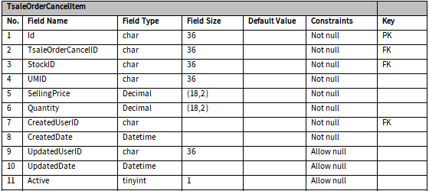

### Sale Order Update

**Process Flow**

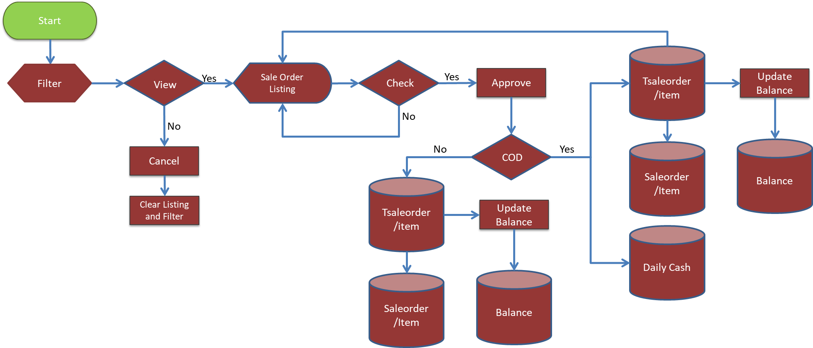

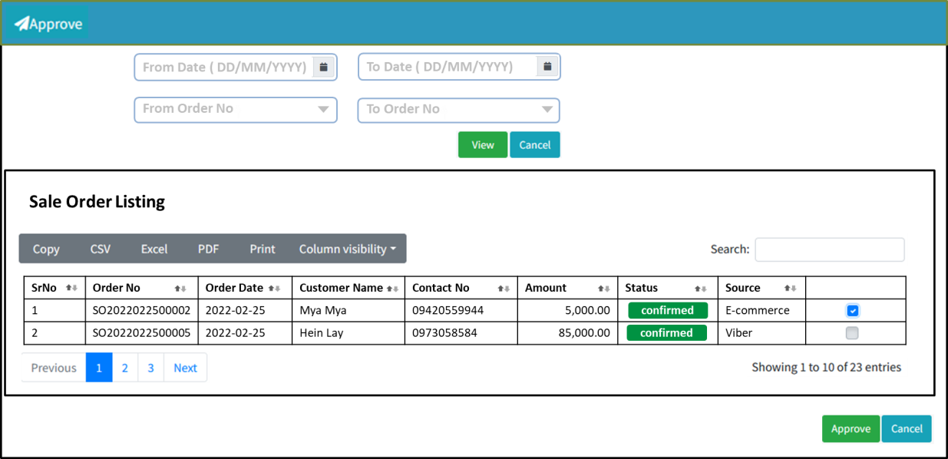

**Table Structure**

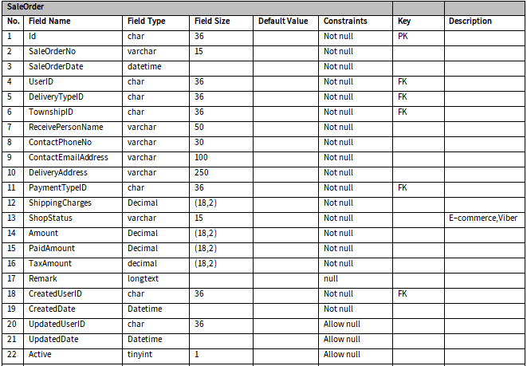

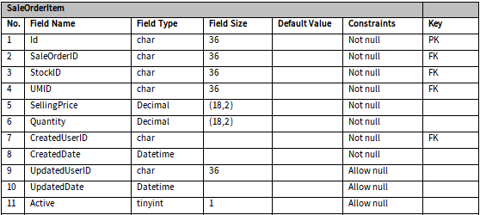

### Sale Order Export

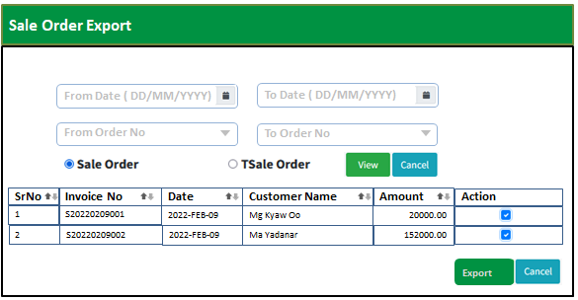

## Delivery Module

**Process Flow**

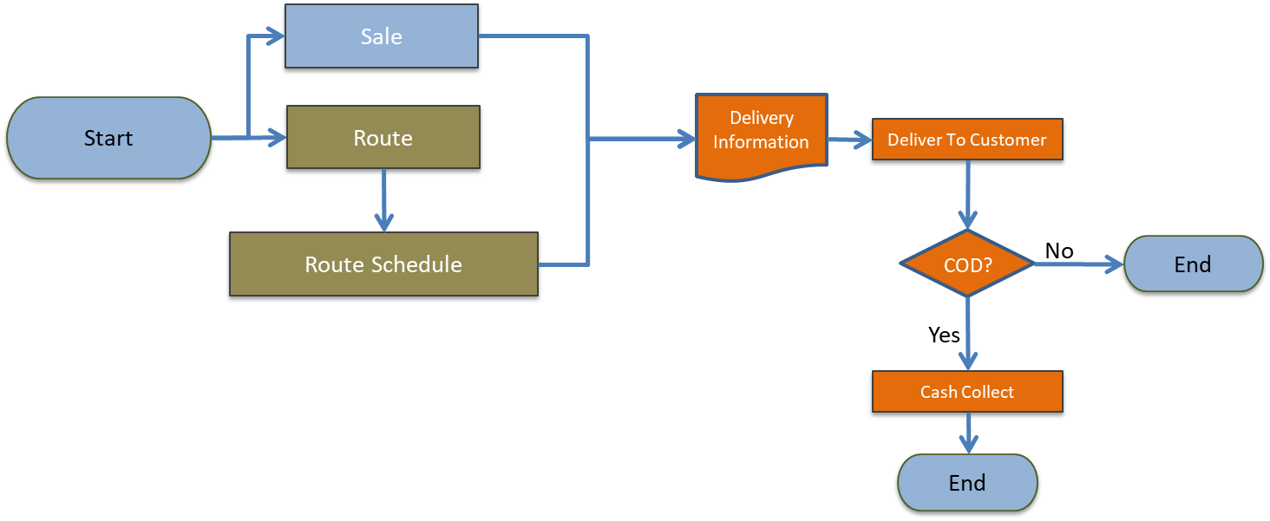

**Entity Relationship Diagram**

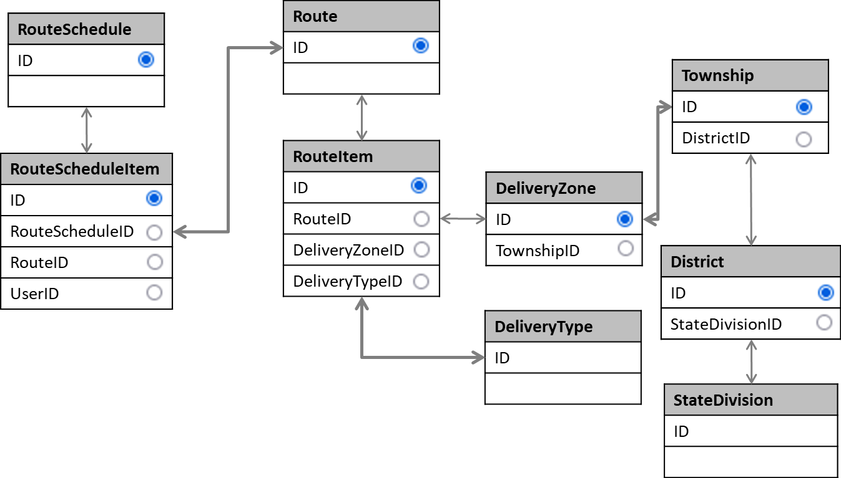

### Route

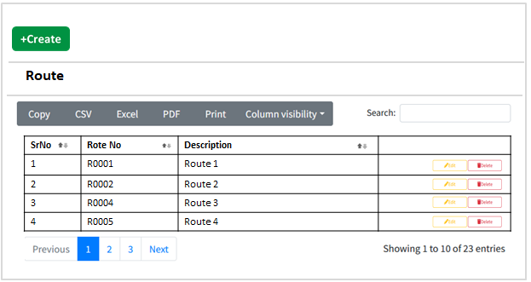

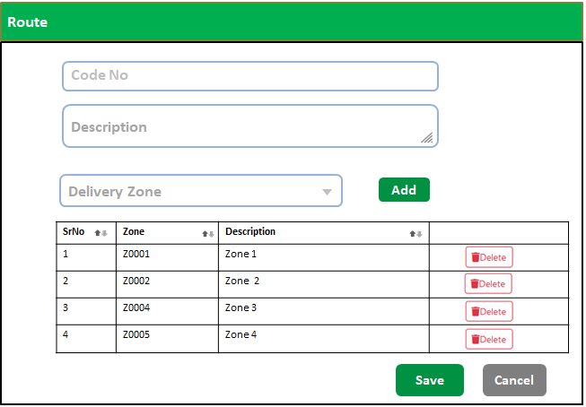

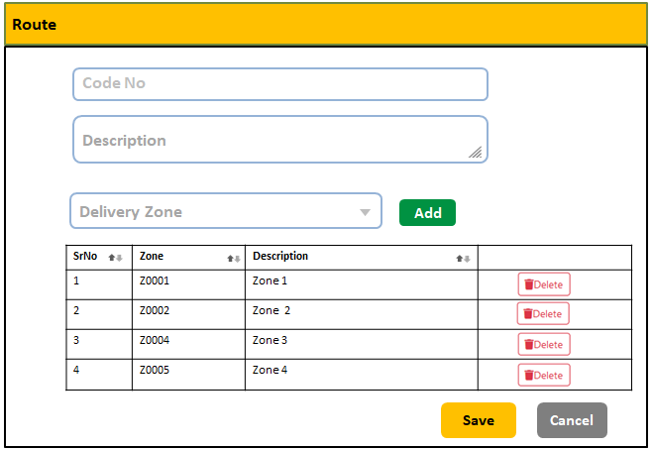

**Table Structure**

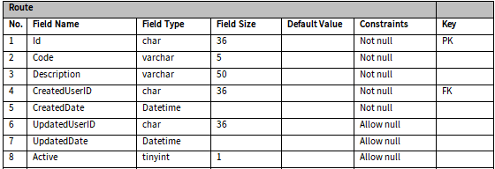

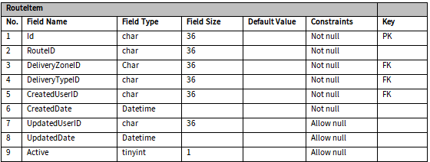

### Route Schedule

**Process Flow**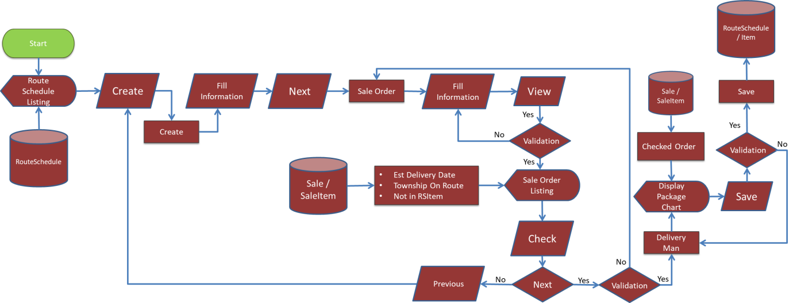

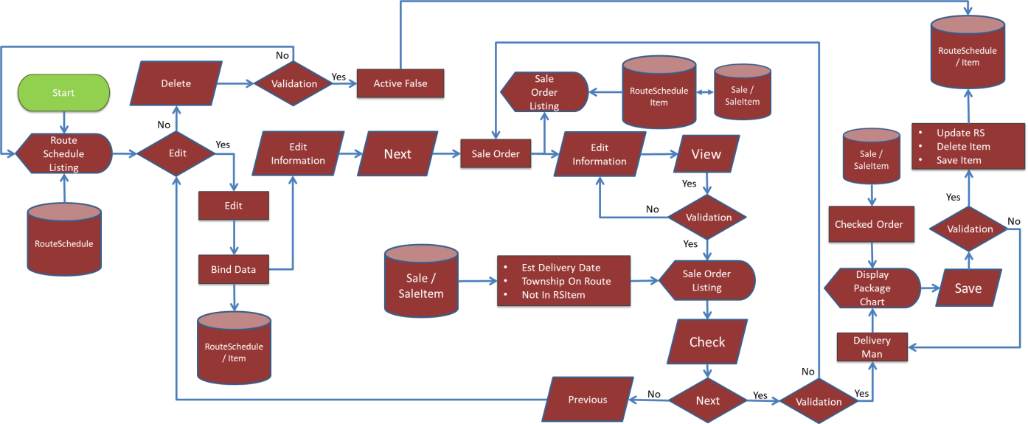

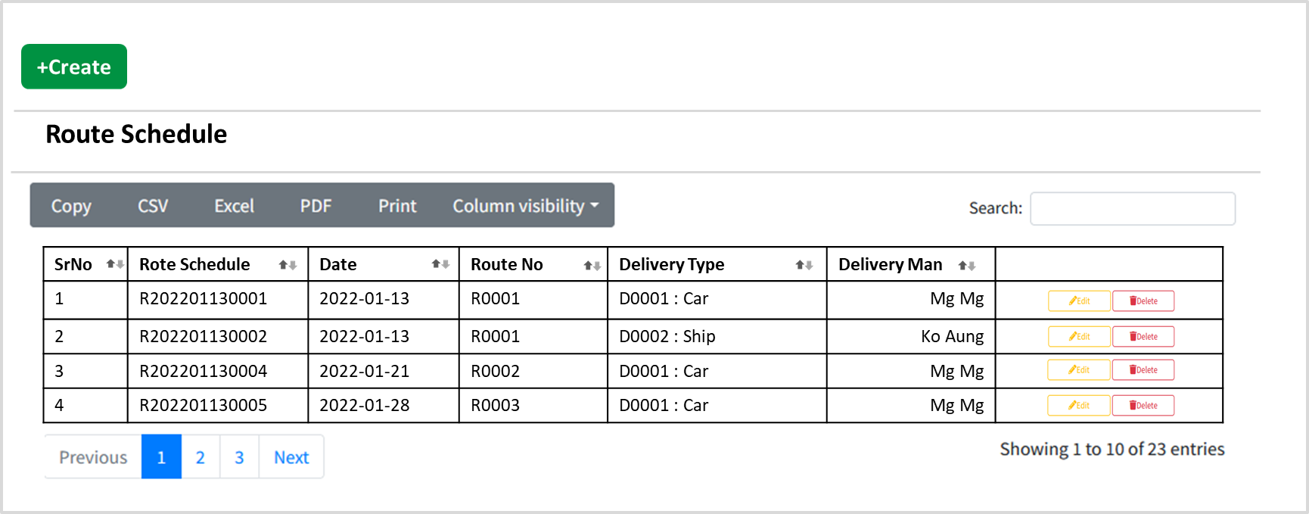

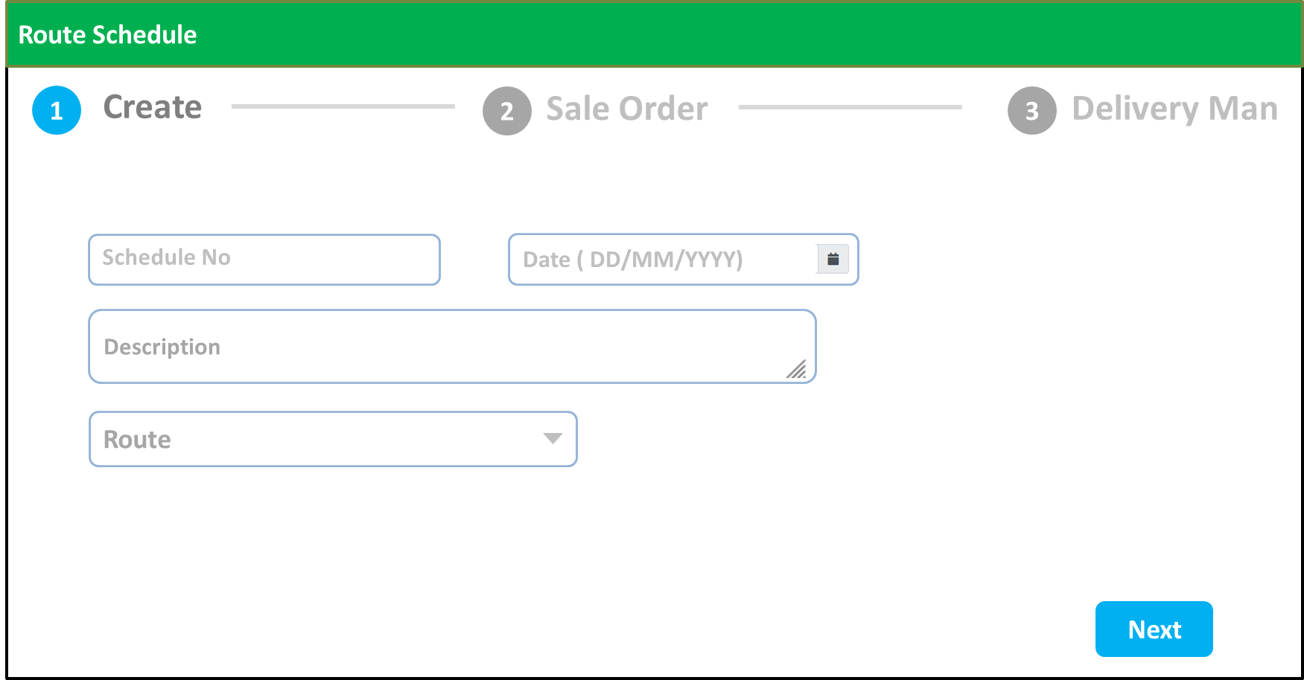

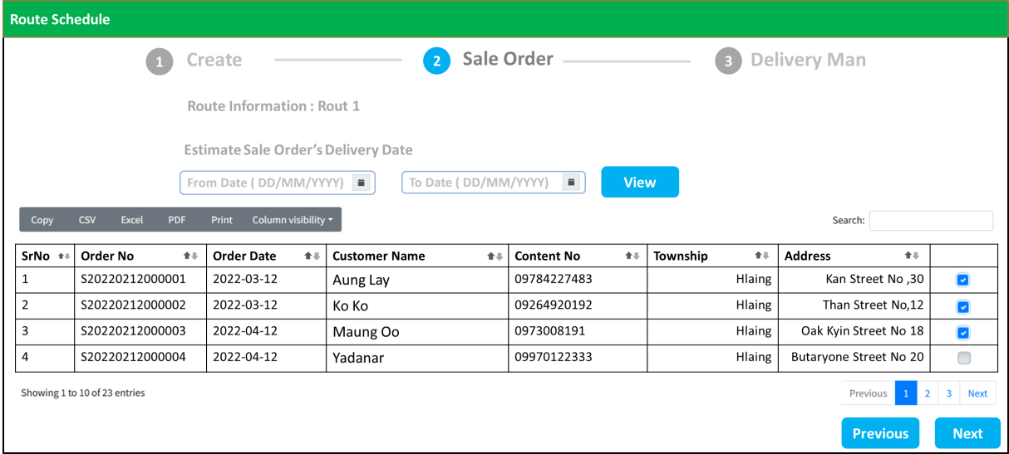

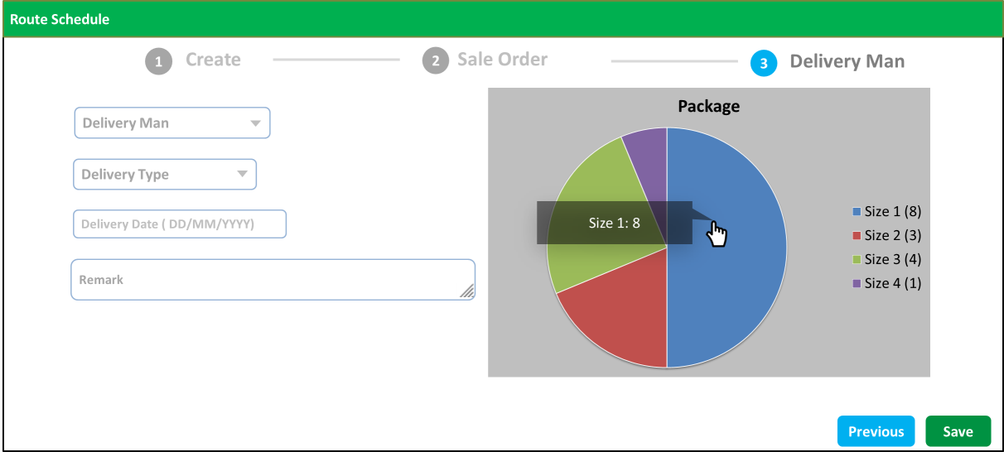

**Table Structure**

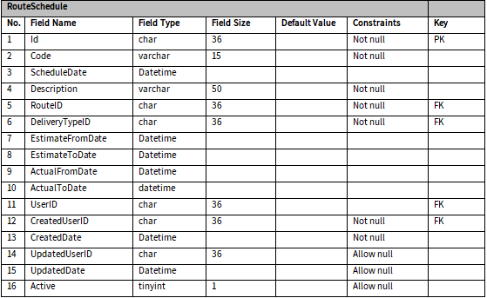

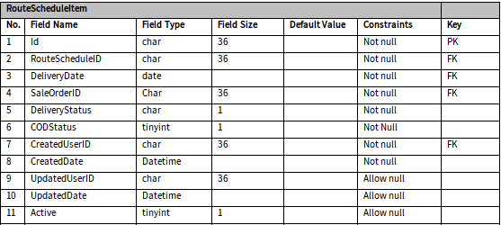

### Daily Route Information

**Process Flow**

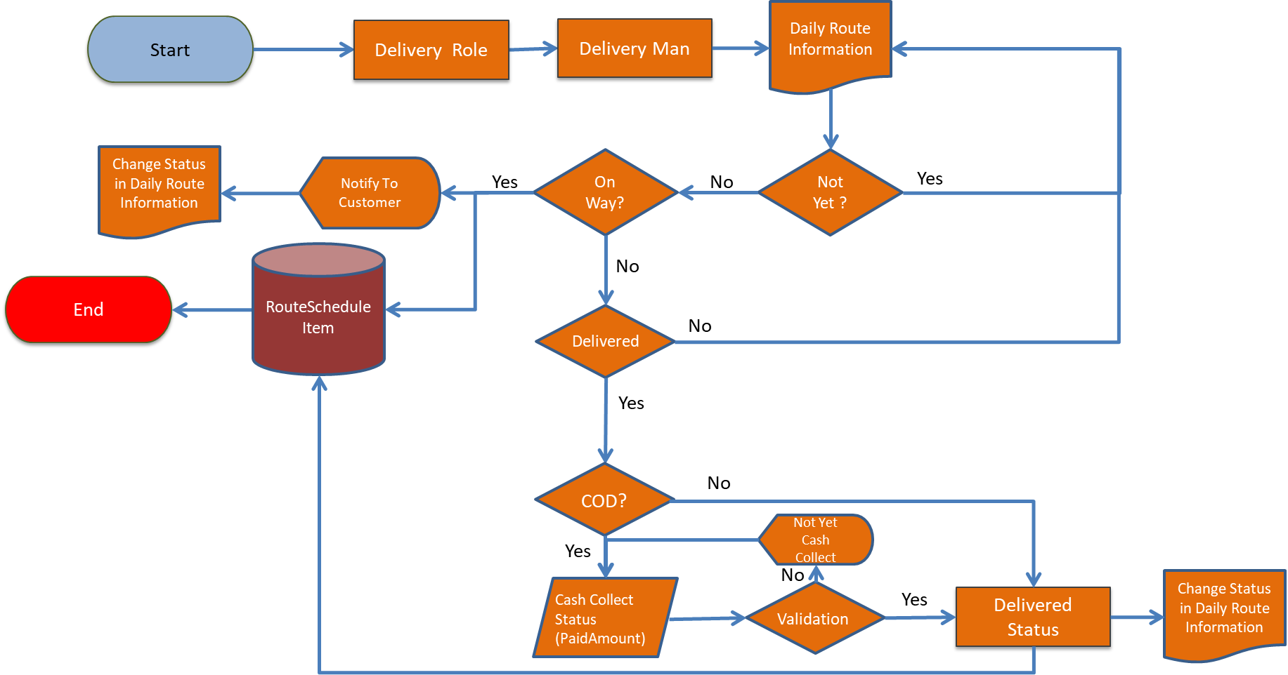

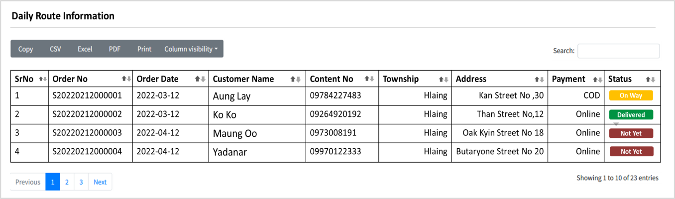

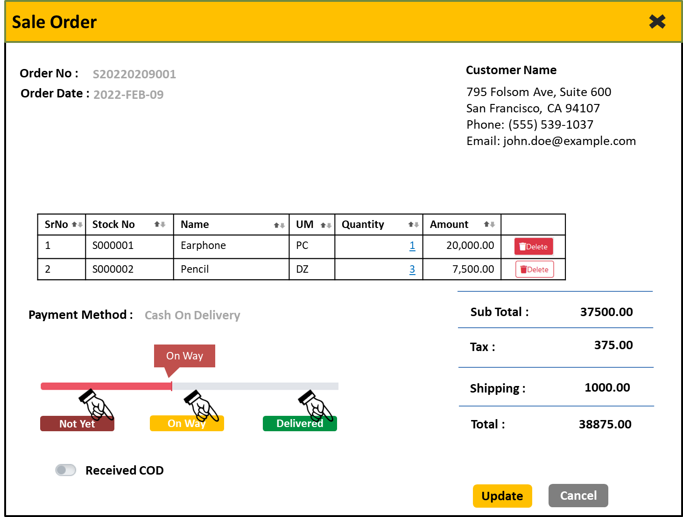

### Cash Collect

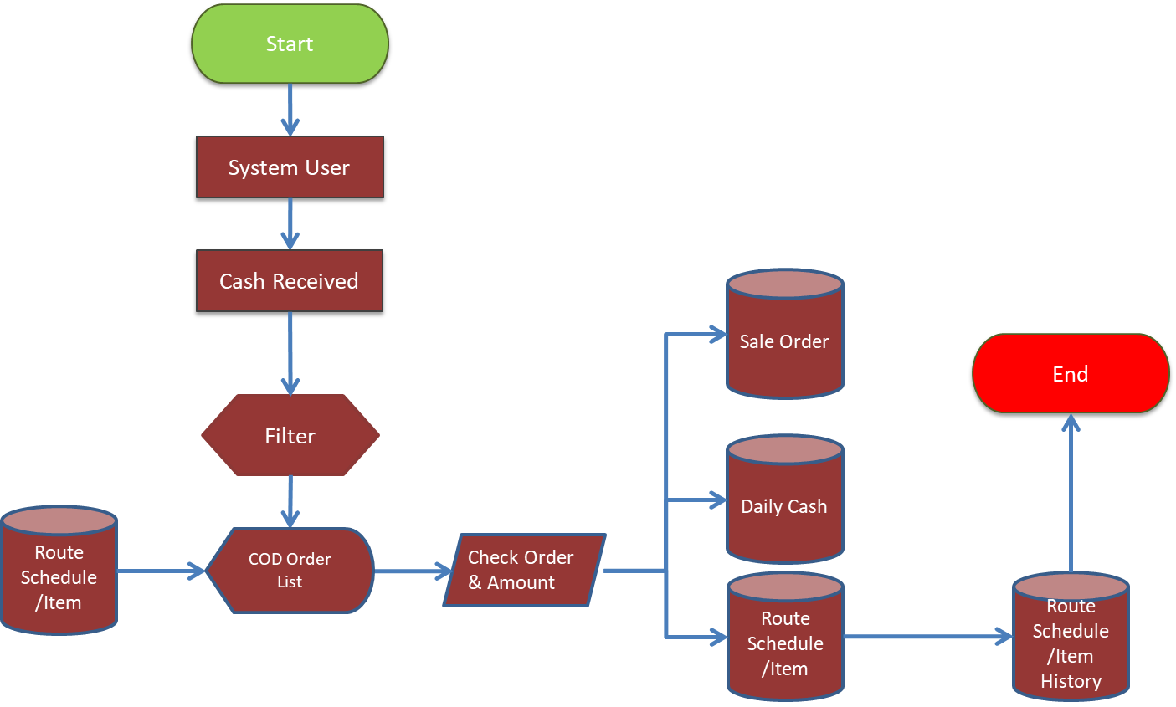

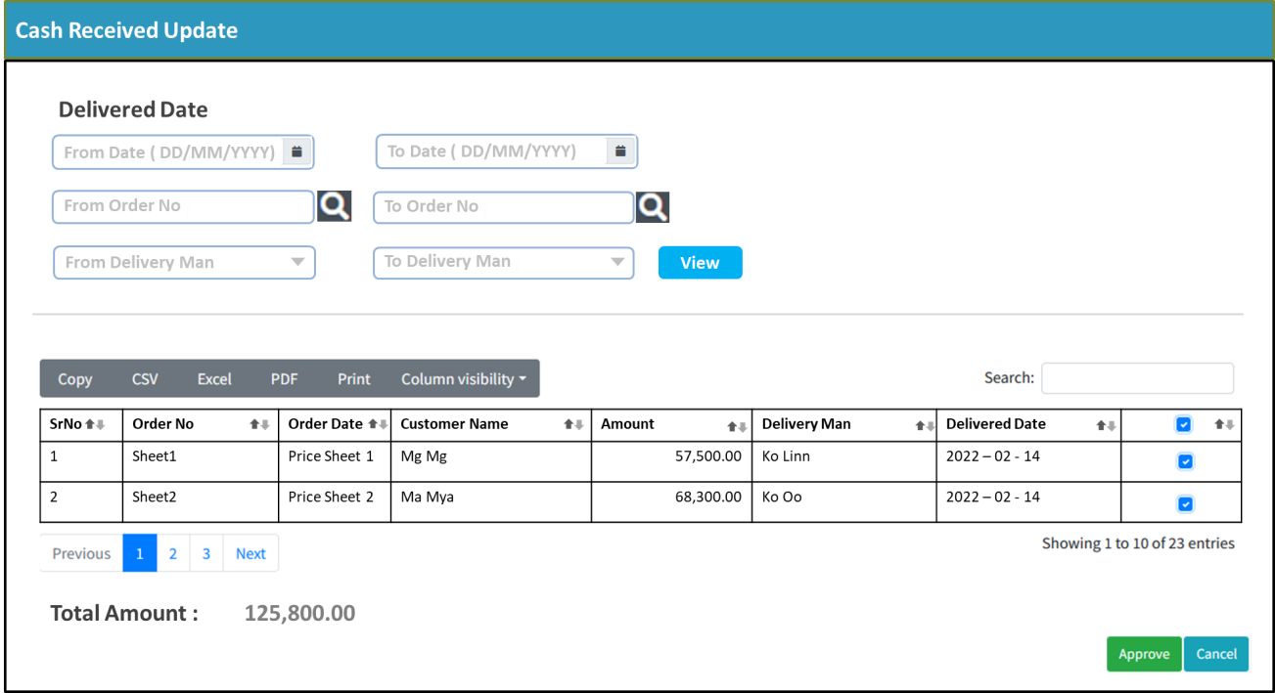

**Table Structure**

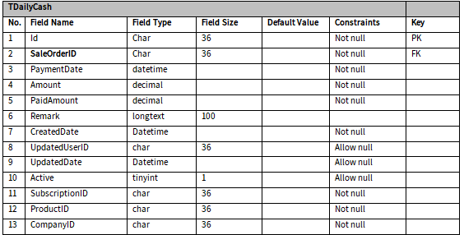

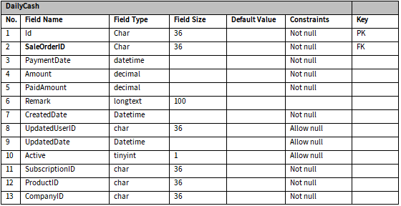

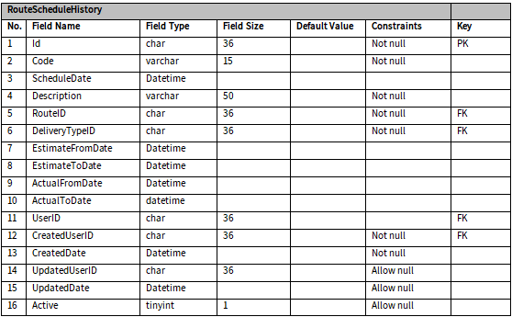

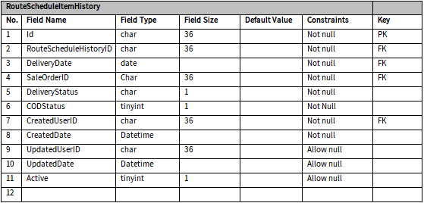

## Warehouse Balance Management

### Warehouse Picking

**Process Flow**



**User Interface**

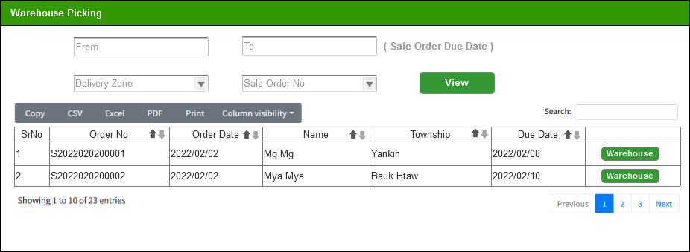

**Sub Process Flow**



**Sub User Interface**

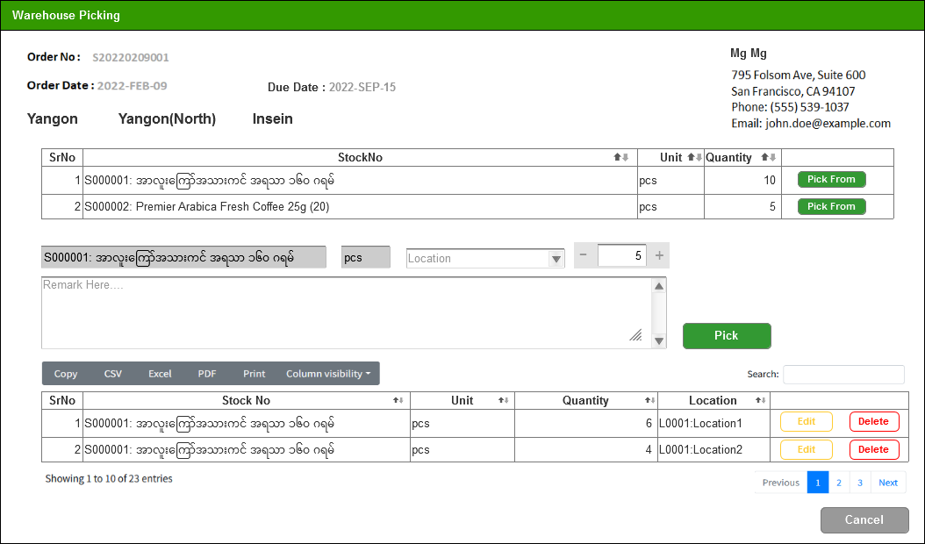

**Table Structure**

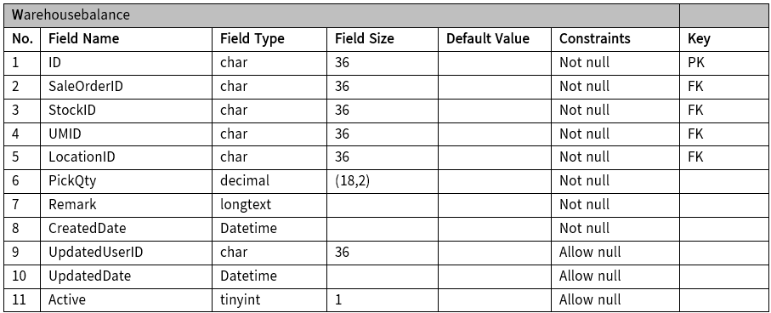

**Entity Relationship Diagram**

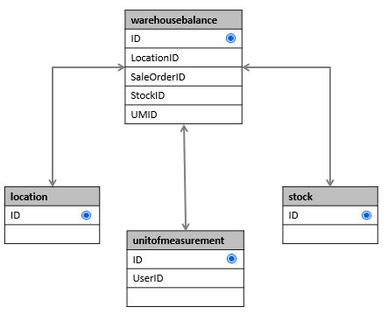

## Multi-Channel Integration

**Process Flow**

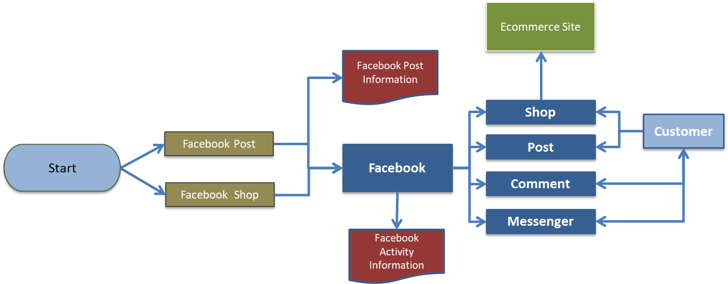

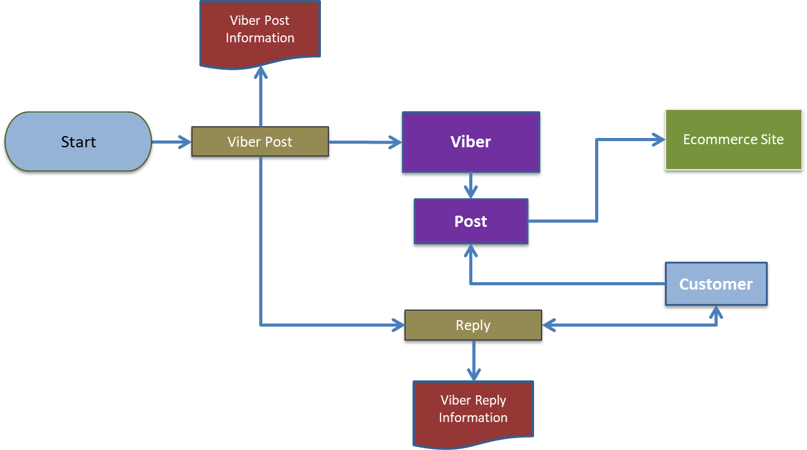

**Entity Relationship Diagram**

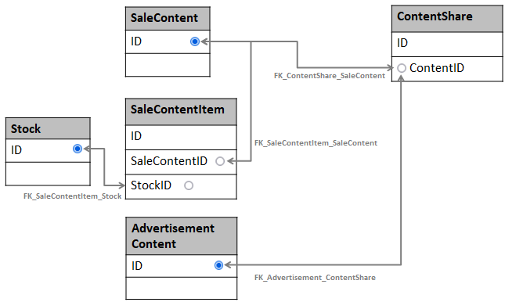

### Sale Content

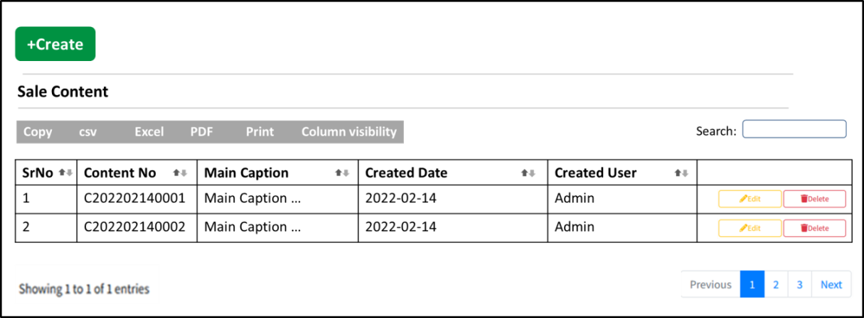

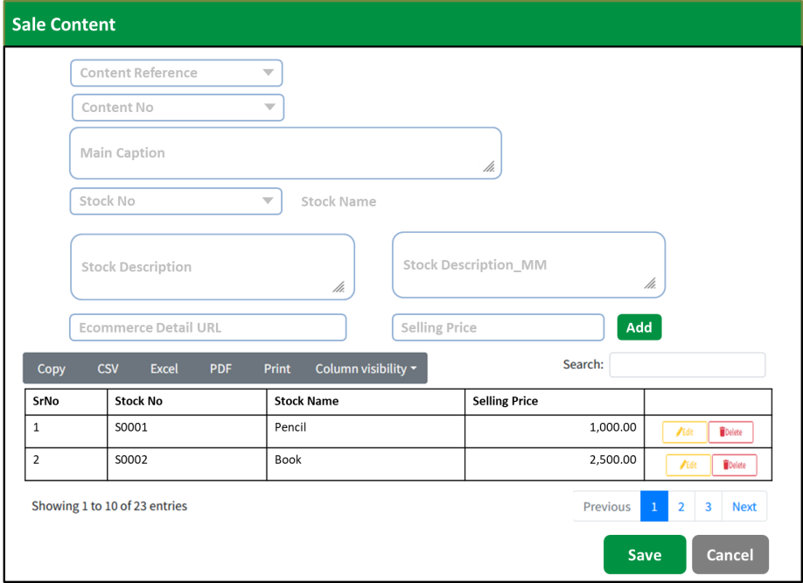

**Table Structure**

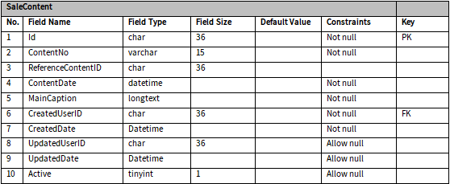

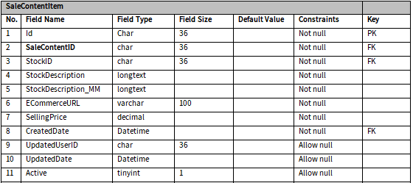

### Sale Content Posting

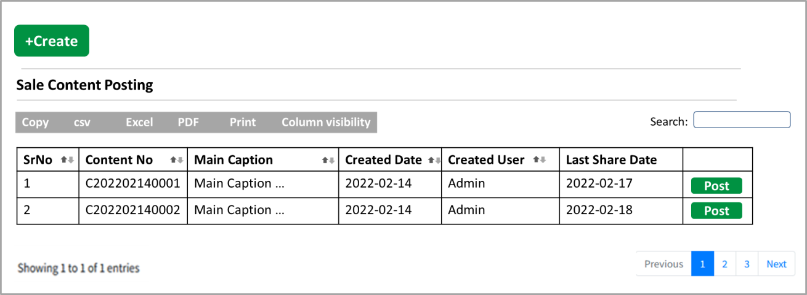

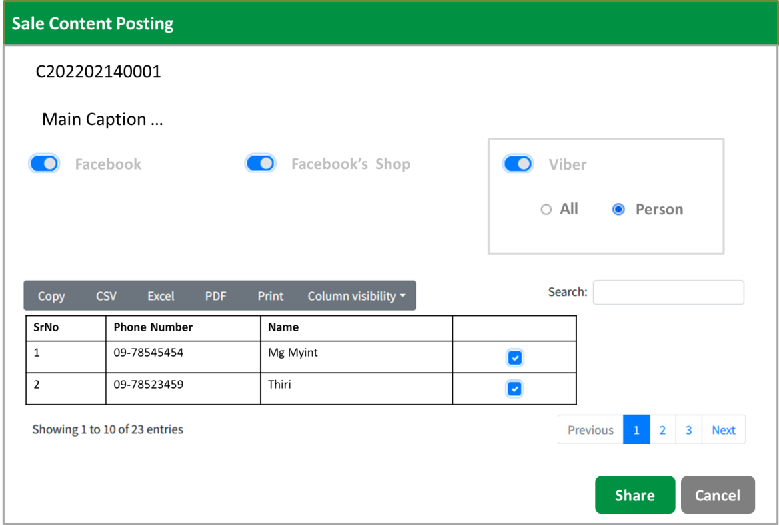

**Table Structure**

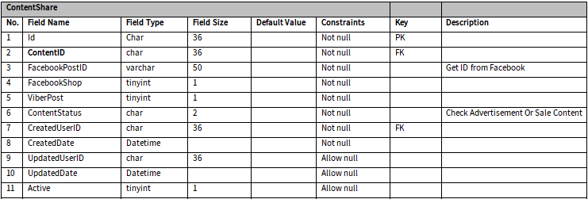

### Advertisement Content

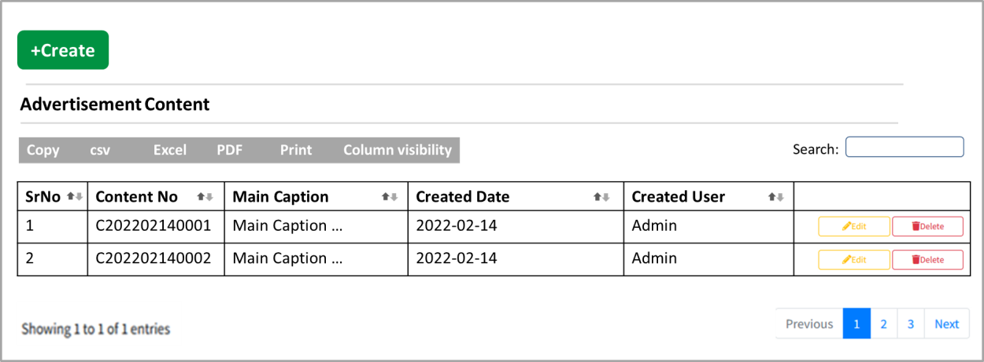

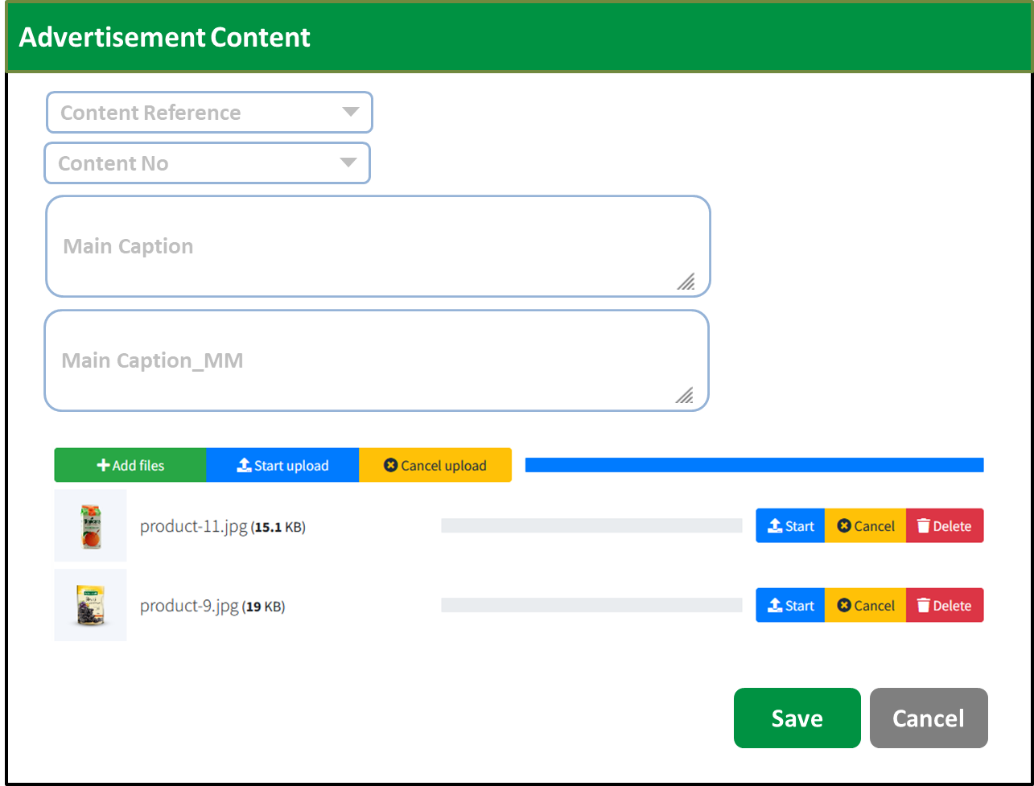

**Table Structure**

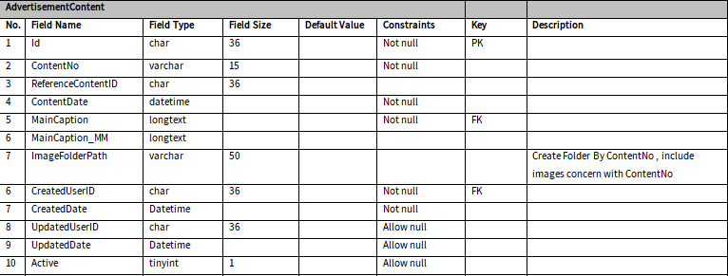

### Advertisement Posting

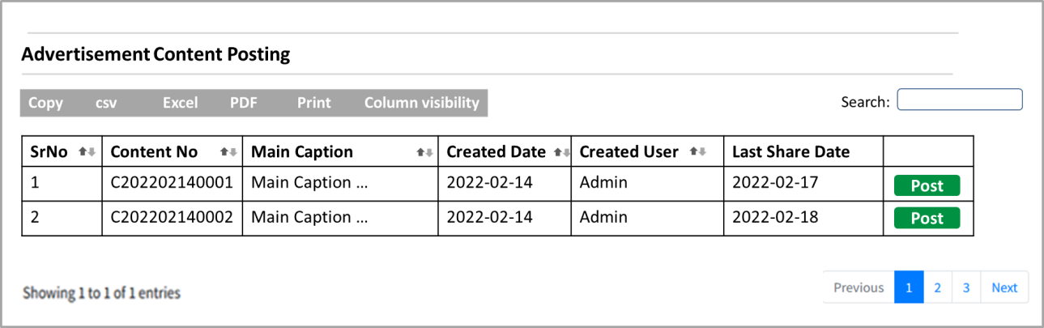

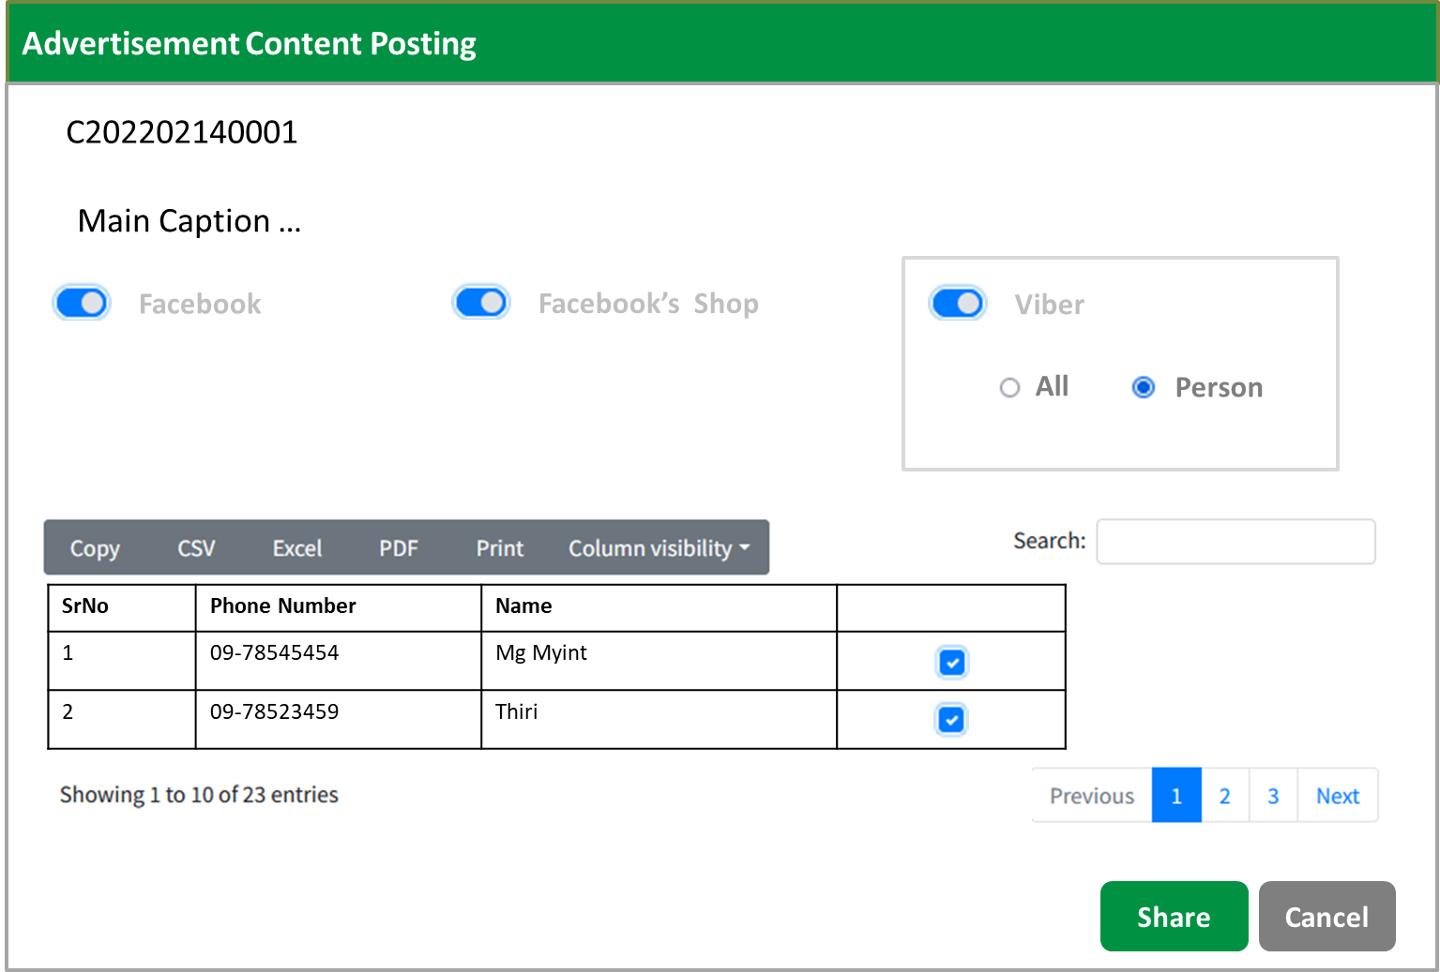

**Table Structure**



## Analysis Report Information

### Multi-Channel Analysis Information

#### Facebook Post Information

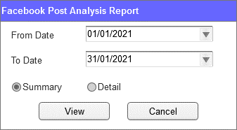

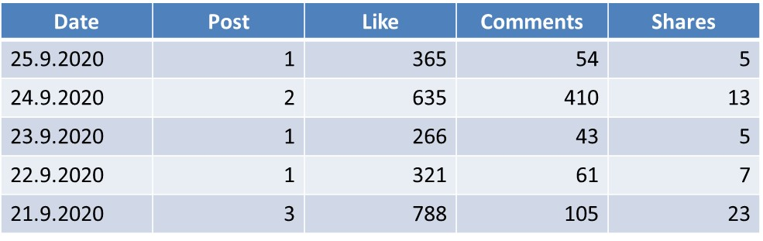

#### Facebook Post by Weekly Analysis

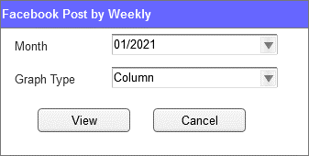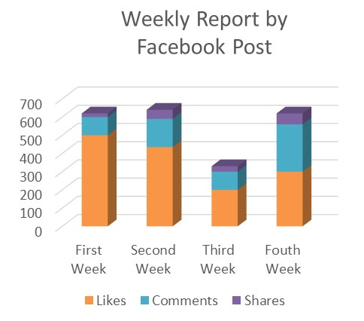

#### Viber Post Information

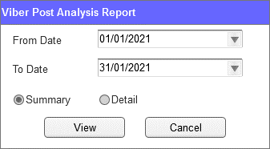

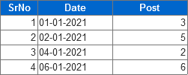

### Sale Order Information

#### Sale Order Information Summary

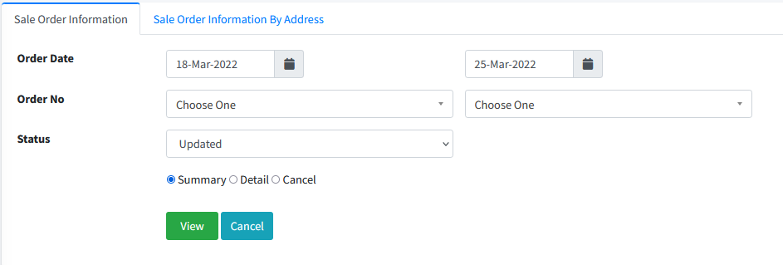

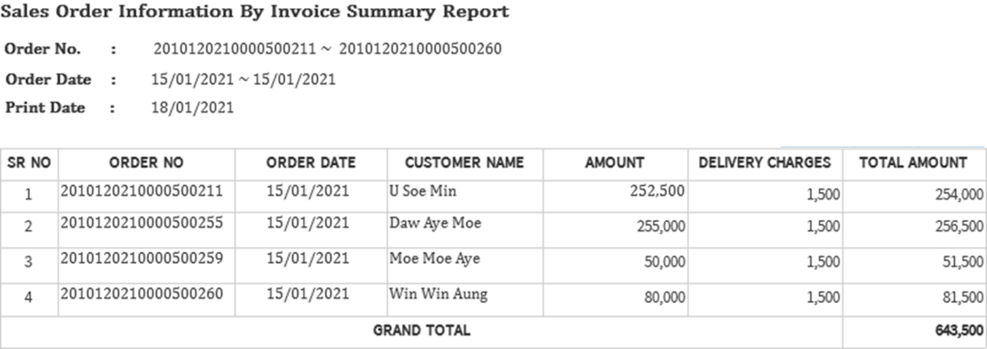

#### Sale Order Information Detail

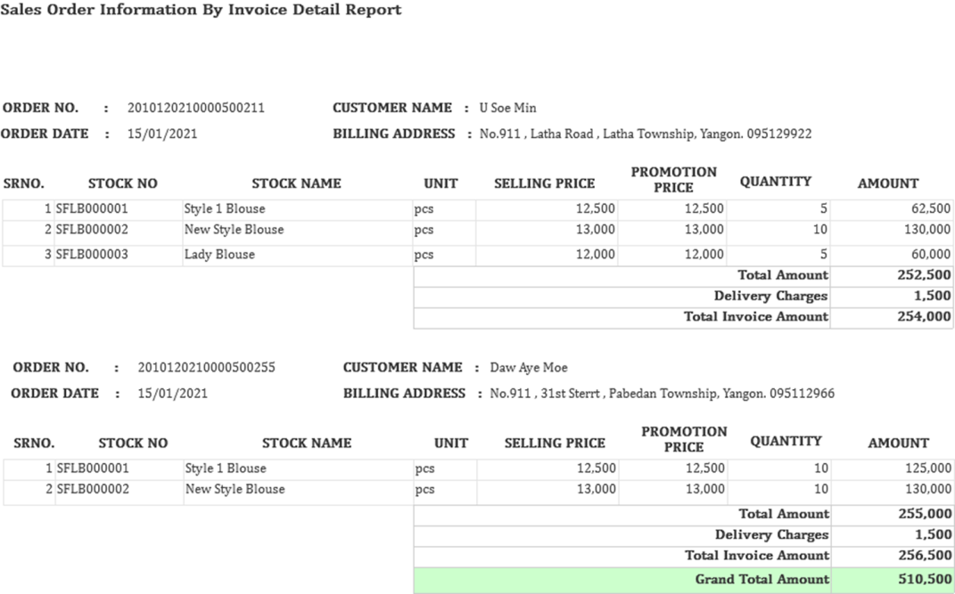

#### Sale Order Information by Address

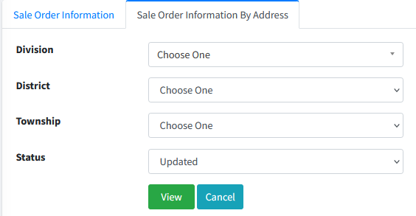

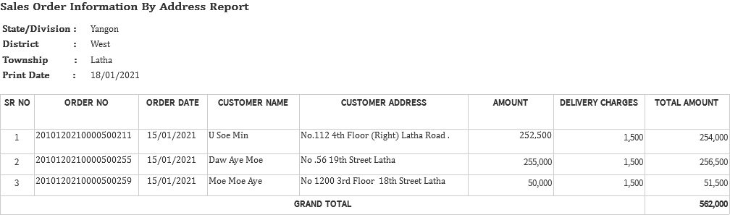

#### Sale Order Cancel Report

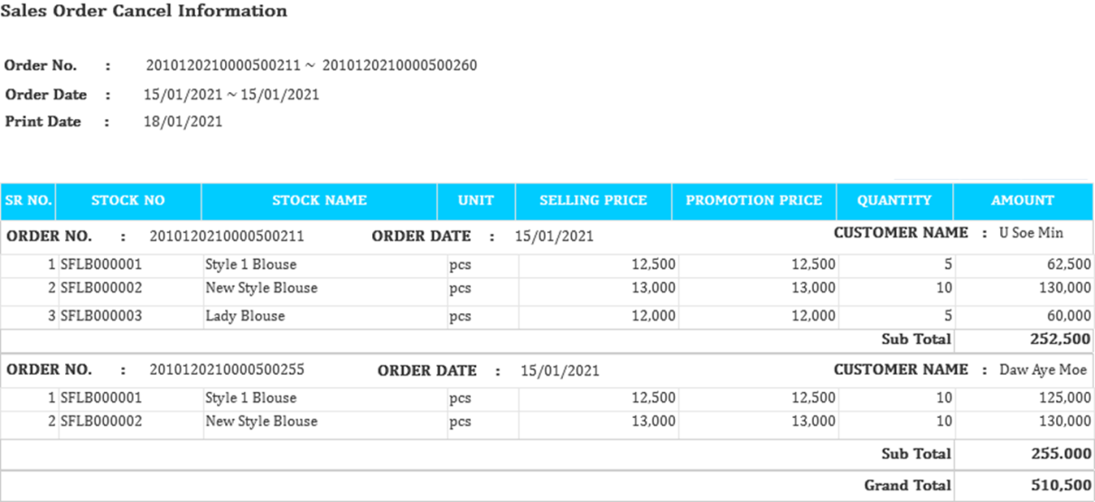

## Dashboard Information

**Process Flow**

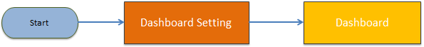

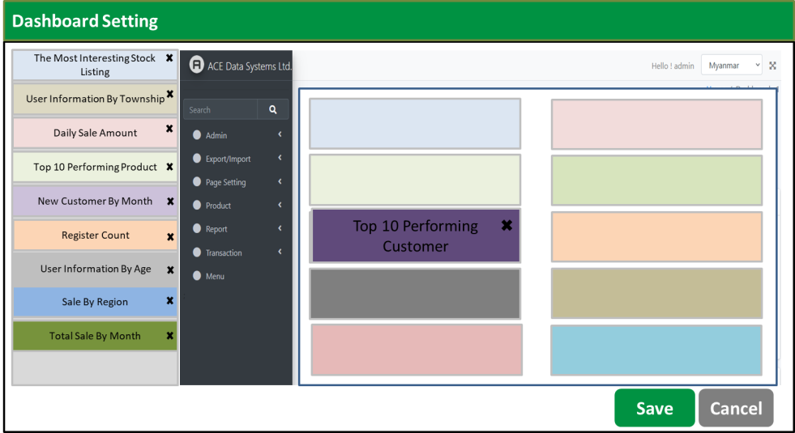

**Table Structure**

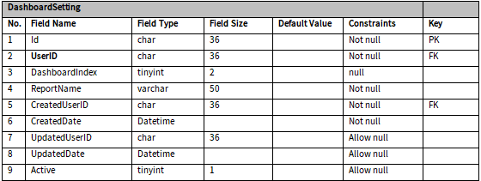

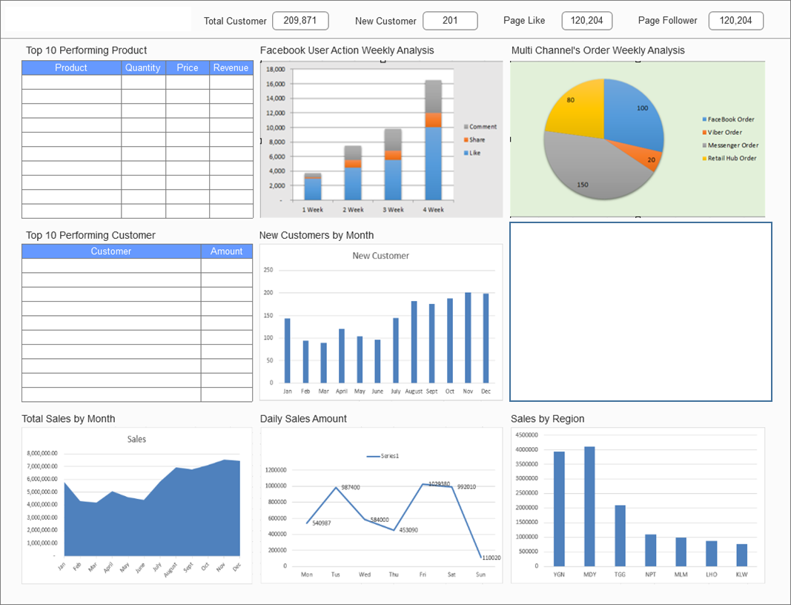

# Front End

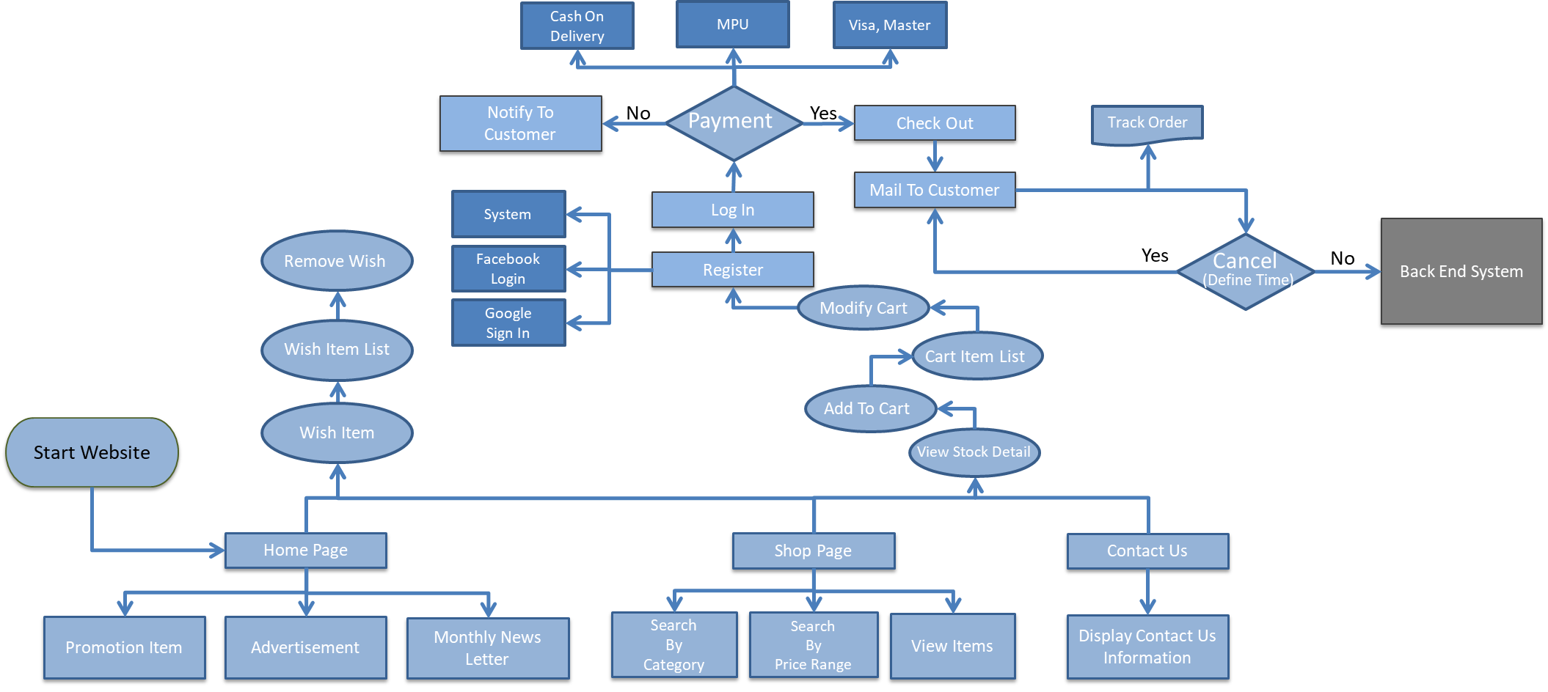

**Table Structure**

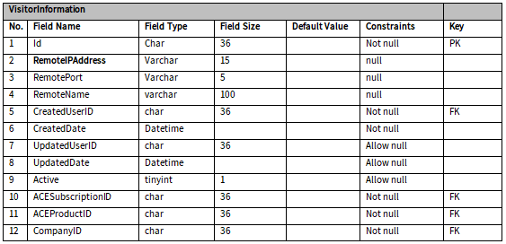

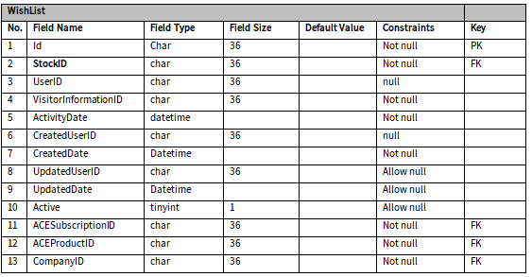

## Log In

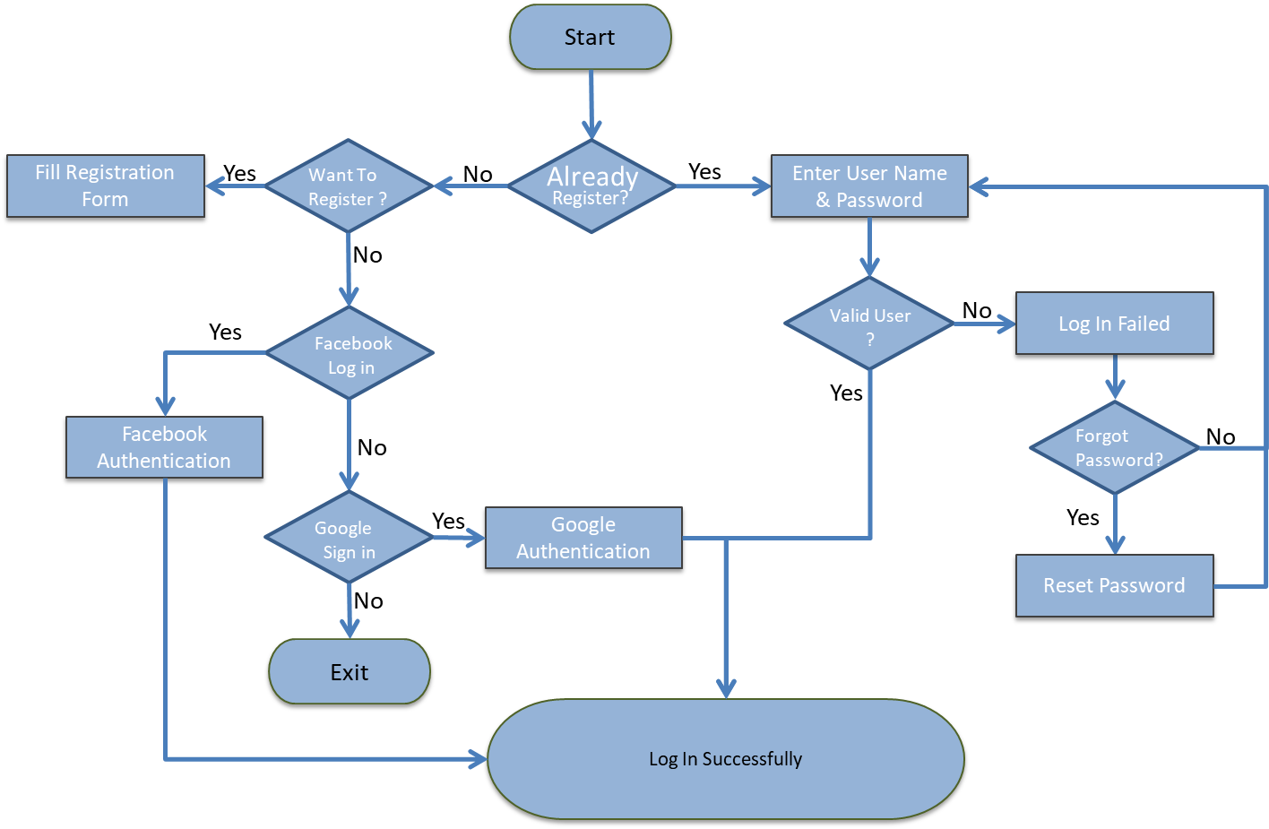

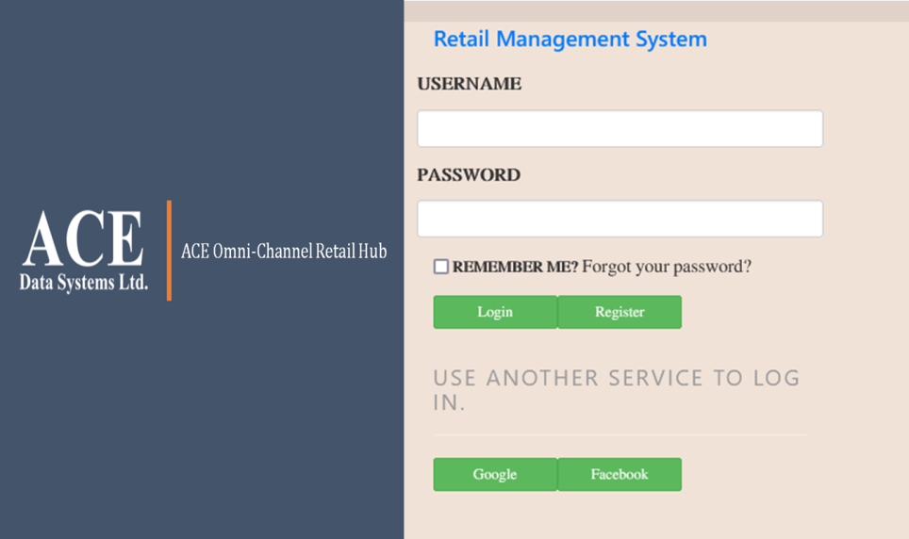

## Register

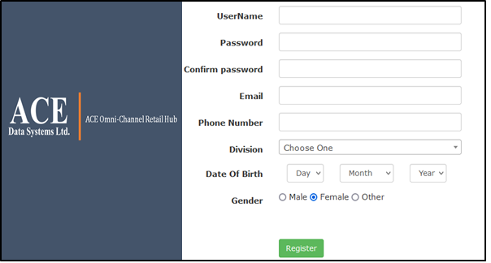

## Home Page

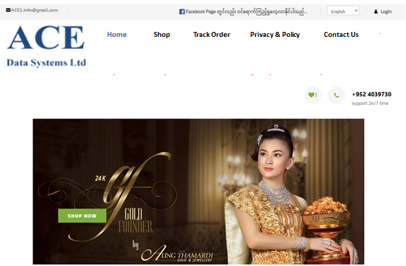

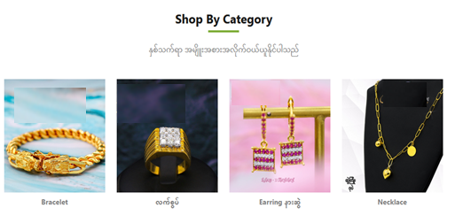

## Shop Page

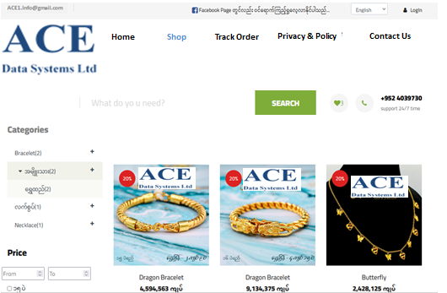

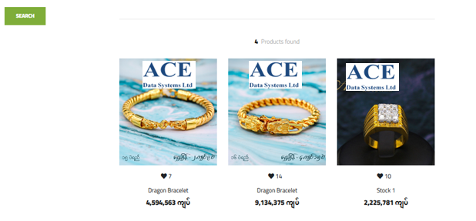

### Detail Page

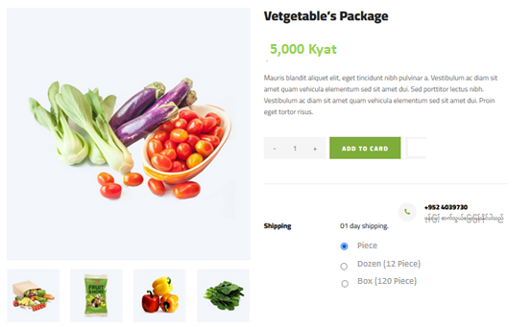

****Shopping Cart****

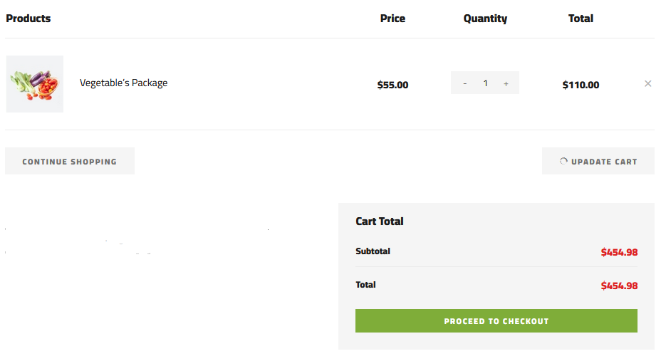

****Payment****

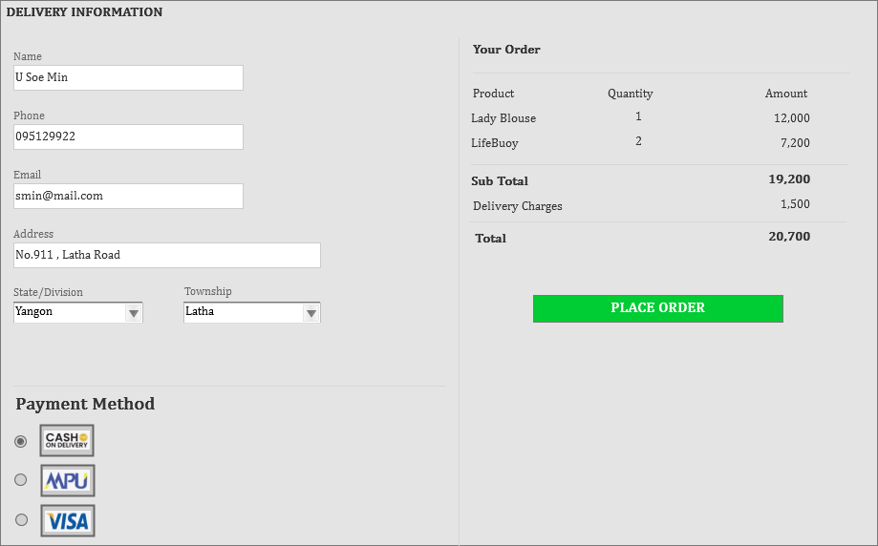

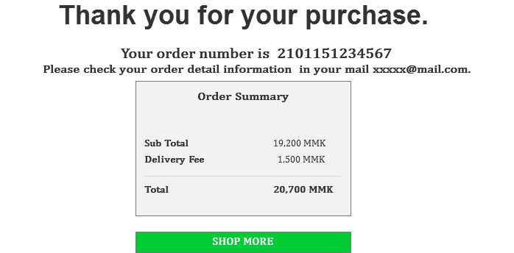



## Contact Us Page

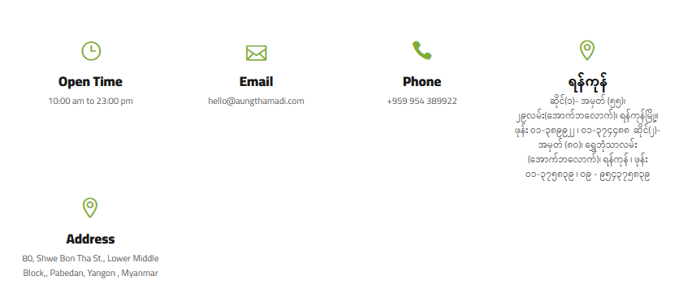

## Privacy & Policy Page

